PROPOSAL UNDER THE
SMALL COMMUNITY AIR SERVICE DEVELOPMENT PROGRAM

MCCOOK MUNICIPAL AIRPORT
NORTH PLATTE REGIONAL AIRPORT
CONSORTIUM

DOCKET# OST-2004-17343
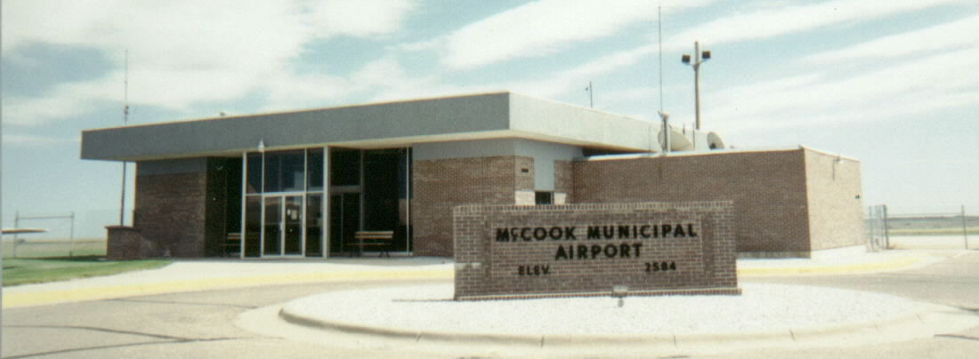
MM McCook
Mu Municipal Airport Airport

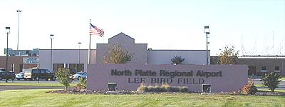
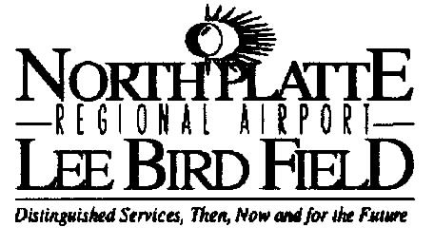

May 5, 2004

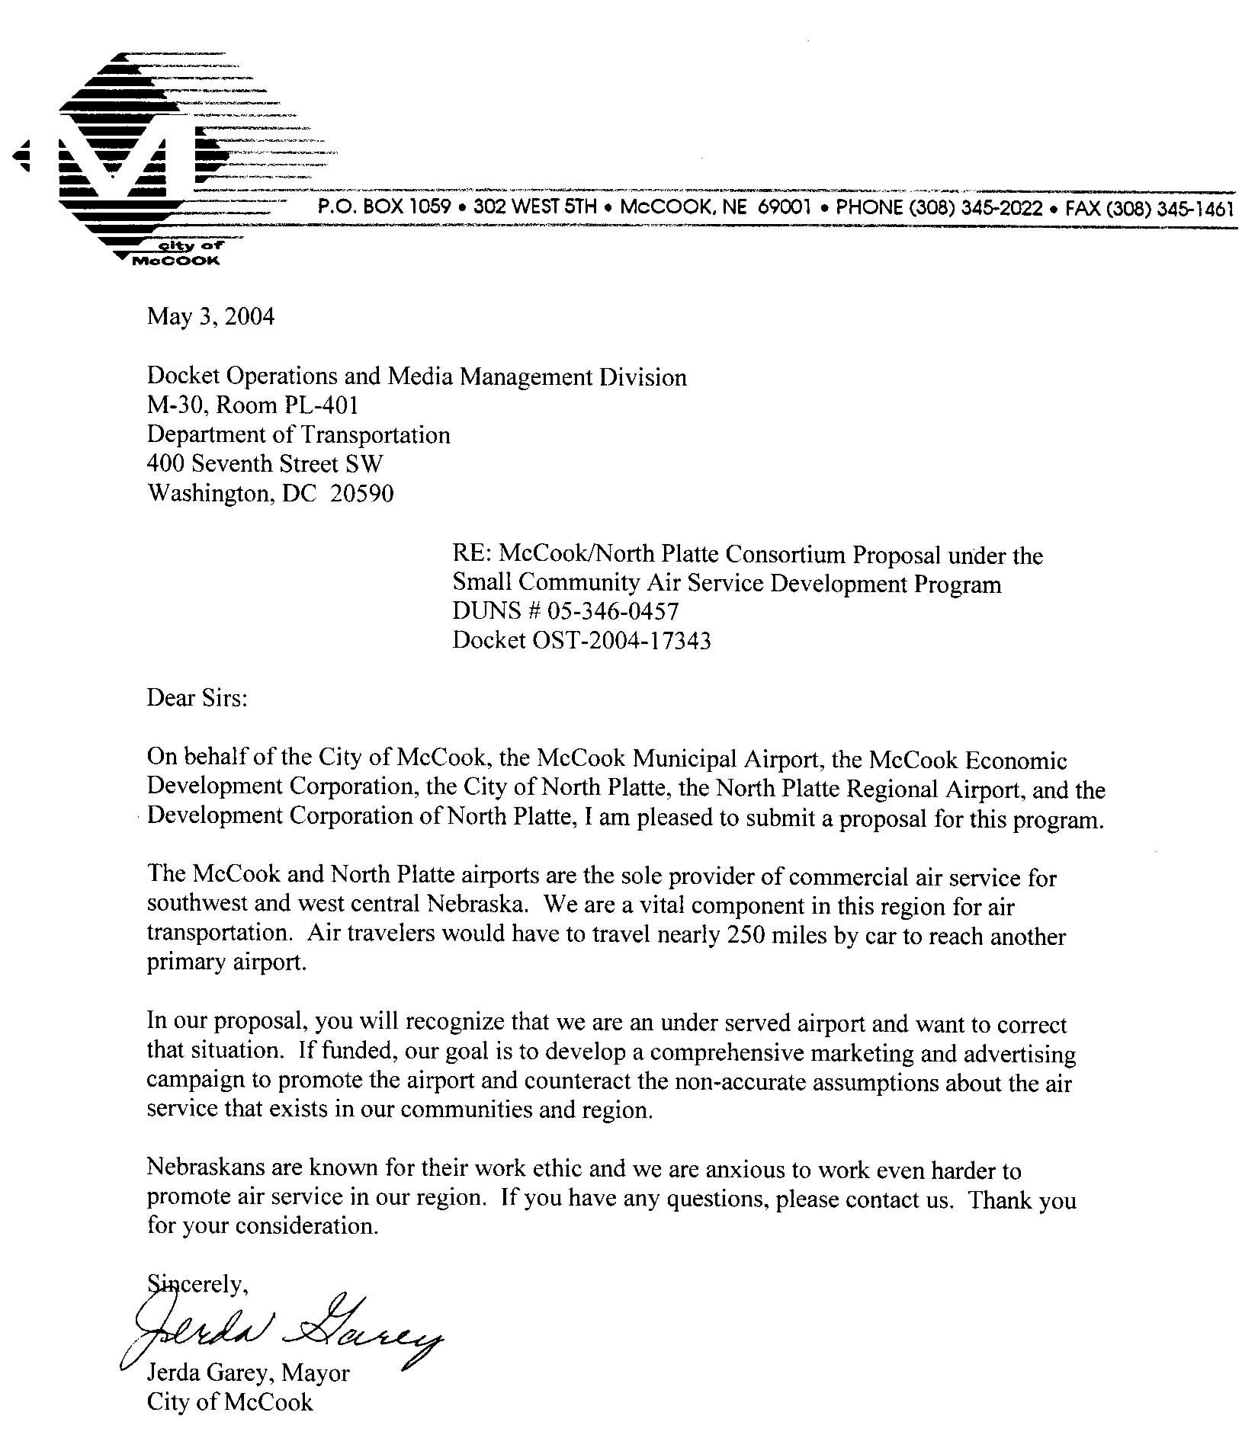

Table of Contents

Section Topic Page

- Proposal Overview 4

- Review of Communities and Region 6

- History of Air Service in McCook & North Platte 13

- Existing Service 16

- Fare Comparisons 19
- Challenges 21

- Action Plan 23

- Timeline 26

- Financial Plan 27

- Private/Public Partnership 28

- Assurances 29

- Availability for Negotiation 30

Contact Information

Appendix

- Proposal Overview

Air service is a key element for the survival and success of rural America. McCook Municipal Airport and North Plate Regional Airport have joined together as a consortium to promote air service for an expansive region in Nebraska and Kansas.

The focus of this proposal is to address the underutilization of the air service due to a lack of awareness by potential passengers. Limited budgets have not allowed for advertising on a regional basis. Our proposal will allow us to develop a positive approach to marketing our airports in this rural region to enhance the level of service provided and decrease our subsidy support.

Goals

 Develop community and regional support for air service in McCook and North Platte through marketing and education

  Enhance the working relationship with Great Lakes Airline serving McCook and North Platte

 Initiate advertising campaign to promote air service and awareness in our region

Challenges

- Poor public perception of available air service

- Marketing of air service in region has been limited due to few resources in rural markets

Opportunity

In our proposal, we plan to:

- Identify our market area

- Create a marketing campaign to increase awareness and usage of our current air service

- Develop a stronger partnership with airlines to improve service for our region

Timeline:

Our proposal will present a view of the two communities joining together, historical air service, and a 36 -month strategic plan. Funding from this grant would be used to initiate a continuing program to which McCook and North Platte would dedicate ongoing investments in time and money.

Finances:

Amount requested from DOT in this grant: $ 275,000
Local Contribution: $ 55,000
Total cost of Program: $ 330,000

2. Review of Communities and Region

It is imperative to keep quality air service in rural Nebraska. Air service is an integral part of rural Nebraska’s plan for economic development and to reverse negative migration trends. Potential employers seeking information on starting or moving a business into southwest or west central Nebraska have always requested additional details about air service. Creating awareness of the improved air service with Great Lakes will benefit businesses, residents and ultimately the rural communities that support them.

North Platte, Nebraska

Located at the convergence of the North and South Platte Rivers, North Platte has a rich aviation history, starting as the site of the first night airmail flight in 1921. The airfield was purchased by the city of North Platte in 1929 and leased to the Boeing Transport Company. In 1941, additional runways were constructed and the airfield became the site of a B-17 training command during WWII. The airport was renamed Lee Bird Field after the son of a North Platte pioneer family who was killed training as a military pilot in 1918.

The airport has been operated as an Airport Authority since July 1963. In recognition of the fact that airline passengers and aircraft owners are drawn to the airport from a large geographic area, the airport was renamed North Platte Regional Airport Lee Bird Field in June of 1992.

North Platte is 283 miles from Omaha Eppley International and 257 miles from Denver International. North Platte has a population of 23,674 according to the US Bureau of the Census, 2002.

McCook, Nebraska

In the late 1940’s the airport property was acquired and runway 12-30 was laid out as a 4,000-by-60 foot sod strip running southeast-northwest. This was followed by asphalt in 1952, runway extensions in 1963-1965 and completion of the airport terminal building in 1969. Additional projects are planned for 2004-2009 starting with improvements to the runway, lighting and the development of a master plan. (Capital Improvement Program in APPENDIX)

McCook is located in southwestern Nebraska, 14 miles from the Kansas border. McCook is 264 miles northeast of Denver and 288 miles southwest of Omaha. McCook has a population of 7,939 according to the US Bureau of the Census, 2002.

North Platte and McCook are regional centers for farming, ranching, cattle & hog feeding, oil production, retail sales, wholesales sales, telemarketing, manufacturing and transportation. Their catchment areas cover a third of the state with a rural population base.
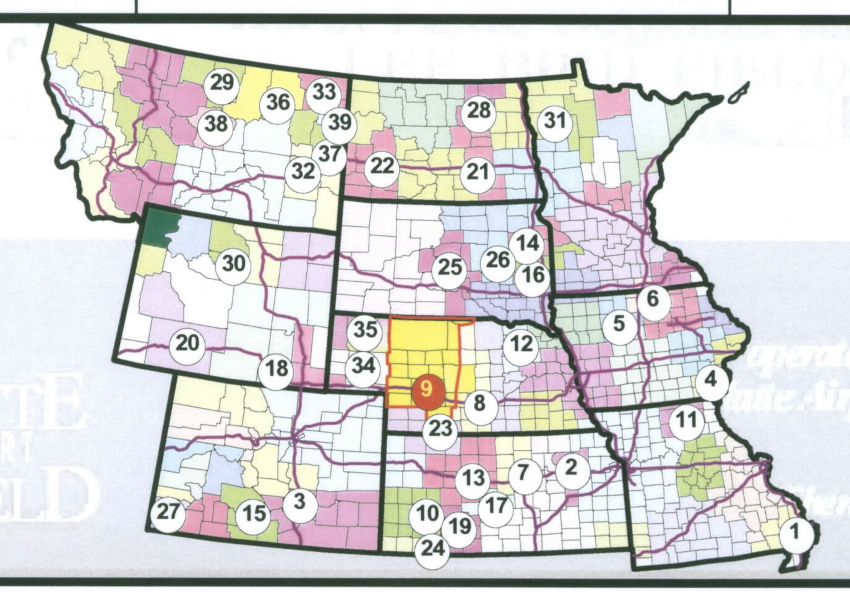

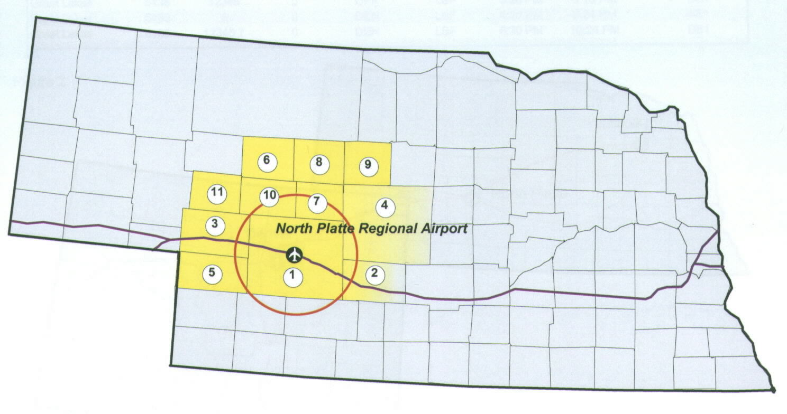

Sixel Consulting Group, Inc. 2002

The following report provides additional insight to the expanse of their regions.
According to a 2002 Market Analysis by Sixel Consulting Group completed for the North Platte Regional Airport, their analysis included:

- North Platte catchment area extends over sixteen (16) counties in west central Nebraska – McCook catchment covers nine (9) counties in southwest Nebraska and northwest Kansas—note that this area runs from the northern to southern border of Nebraska

- North Platte catchment population 84,398 – McCook catchment area population 38,942 for a total of 123,340 (ranking 5th overall in the Upper Midwest Region)

- North Platte’s area is comparable in size to Cheyenne, Great Falls and Casper

- 9th largest Essential Air Service market in the region – McCook is 23rd largest

- Increase of 4,700 residents since 1990 places North Platte 10th among Essential Air Service markets

- Over $2.1 billion in personal income earned by residents of the North Platte Airport Catchment Area ranks 48th among 97 regional markets and 10th among regional Essential Air Service markets – McCook ranks 22nd in EAS markets

- Based on six different economic and demographic indicators, the North Platte Airport Catchment Area has the Upper Midwest Region’s 48th largest economy and the 11th largest economic and demographic base among Essential Air Service market – McCook is ranked 24th in the EAS market

At the conclusion of the study, the Sixel Consulting Group recommended several solutions including, “an intensive advertising campaign touting the air service.”

Our proposed marketing campaign will encompass a large rural area and numerous types of employers. Following is a list of the largest employers, noting that our agriculture base is mainly independent ranching and farming.

Largest Employers and Key Stakeholders in the Consortium Catchment Area:

Union Pacific Railroad (2,518 employees)
Great Plains Regional Medical Center (646 employees)
Wal*Mart Food Distribution Center (533)
North Platte Public Schools (518)
Wal*Mart (374)
Cabela’s (305)
City of North Platte (302)
Nebraska Public Power District (276)
Mid-Plains Community College (162)
Masonite International (145)

Parker Industrial Hone (276)
Wal*Mart Super Center (265)
Community Hospital (247)
McCook Public Schools (183)
Hillcrest Nursing Home (158)
Valmont Irrigation (154)
Kugler Oil Company (96)
Burlington Northern Santa Fe Railroad (86)
City of McCook (77)

Healthcare

Healthcare is one of the largest employee groups in the region. Great Plains Regional Medical Center and Community Hospital account for nearly 900 employees. McCook and North Platte have approximately 160 beds and serve as full-service, not-for-profit medical centers that offer inpatient and outpatient services to patients that may travel a long distance to receive healthcare. Physicians travel by air or ground from larger cities to McCook and North Platte to treat patients. The hospitals require air service when recruiting doctors and other professionals, as well as for business-related travel.

Gary Bieganski, President of Community Hospital states, “The delivery of health care is constantly improving though changes in technology, new procedures, and advances in medical education. To remain in the mainstream of these ever increasing changes, this demands constant continuing education, consultative visits and specialized services. For our physicians, physician assistants, patient care and ancillary staff to be able to attend programs in a reasonable timeframe, it is very important to have air service. We also have great need for our consulting specialists and educators to be able to fly in and work with us. Our only alternatives are to drive a distance to Denver or Omaha to catch flights. This factor causes an additional one to two days away from our facility and physician practices thereby creating great difficulty for patients who rely upon us for their healthcare needs. Air services help our providers to be in the office providing care more days and still are able to meet their necessary and required education commitments.” (complete statement in APPENDIX-letters of support)

Agriculture

Agriculture is not typically a large patron of air service, but in this region, agriculture has expanded beyond the traditional family farm. Within a 30-mile radius of McCook, three new ethanol production facilities are under construction. Technicians, investors and staff are traveling from several states to begin these operations. Upon completion, they will become major employers in this region.

Transportation

Union Pacific Railroad and Burlington Northern Santa Fe Railroad are the combined largest employers (2,600) in this region. Training is a key component for their success and air service is critical to the delivery of this training. Union Pacific is headquartered in Omaha and the addition of the River Run by Westward Airways will significantly affect this situation.

Tourism/Recreation

Tourism and recreation are ‘unsung heroes’ in economic development. According to the Nebraska Division of Tourism, the Prairie Lakes and Sandhills regions are filled with attractions, adventures and accommodations. Destination areas within the region include: Buffalo Bill Ranch State Historical Park & Recreation Area, Dancing Leaf Earth Lodge & Cultural Learning Center, Senator Norris Home & State Historical Site, Champion Mills State Historical Site, High Plains Museum, Massacre Canyon Memorial Site and several others. Recreational visitors have discovered the abundance and quality of fishing, boating, skiing, rodeo, hunting and golfing in this region. Events such as Nebraskaland Days and Heritage Days bring in significant number of visitors to North Platte and McCook. Air service is most influenced by the large number of recreational visitors to this region.

Fishing guide, Steve Lytle of McCook has clients from all over the United States who annually make trips to fish on his boat. Numerous hunting opportunities exist, especially for pheasant season. From professional guides to local farmers, the opening of pheasant season will triple the size of communities in southwest Nebraska. Providing more seats and better scheduling through air service would greatly enhance the impact of pheasant season.



Heritage Hills Golf Course in McCook is rated in America’s 100 “Greatest Test of Golf” by Golf Digest. PGA professional, Lee Maiden has promoted the “Play the West” golf package/vacation in Western Nebraska with a joint venture between the McCook course and golf courses in Kearney, Gothenburg, Ogallala and Cambridge. Hotels are involved in McCook, Ogallala, Gothenburg and Kearney. In 2002-2003, they were reaching an audience mostly from Eastern Nebraska. In 2004, “Play the West” received a marketing grant from the Nebraska Department of Tourism to pursue Denver and the Front Range. From 300 visitors in 2000 to 1400 in 2003, this golf package has been very successful. Their next step is partnering with the airports in McCook and North Platte to provide more convenience for their customers. Affordable rates and convenient schedules can enhance the opportunities for success.
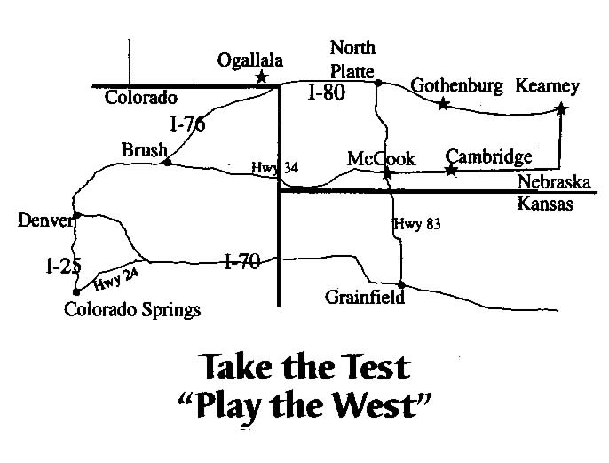
The Nebraska Division of Tourism uses a multiplier of $2.70 for every dollar spent by a tourist that goes into a regional economy. Air service can make a significant economic impact on rural Nebraska.

The recently completed Nebraska Aviation System Plan provides the Nebraska Department of Aeronautics with a blueprint on how to best develop and invest in its airports. It is noted in this report the strong relationship between the state’s economy and its transportation system, including its airports. Airports in Nebraska are key supporters of and contributors to the State’s economy. In today’s global marketplace, no state can keep pace without a diversified and well-maintained transportation system. Results of a recent economic impact study revealed that $1.7 billion in annual economic activity is supported by Nebraska’s Airport system. Over a 20-year period, approximately $500 million will be needed to improve all Nebraska airports. The annual return on the investment clearly justifies the State’s intent to invest in and develop Nebraska’s important airport resources.

McCook Municipal Airport is beginning their capital improvement program with these funded projects:
2004
Precision Approach Navigation Aid (FAAAF)
TWX: Rehab portions of Runway
AP: Apron & Hangar Taxiway B Pavement Repair
HT: Hangar Taxiway Repaving
RW: 6” PCC Pavement on Runway
2007
Replace runway lights
Replace taxiway lights
2009
Snow Removal Equipment
Update Master Plan
Crosswind Rwy/Txy Light Extension
Grade Runway Extension
Crosswind Runway/Taxiway Extension

3. History of Air Service in McCook & North Platte

Air service in McCook and North Platte has been filled with inconsistent schedules and lack of seats that has ultimately reduced the number of passengers to travel from their airports.

McCook Air Service History

Air service at the McCook Municipal Airport has existed since 1949. Midwest Airlines was the first carrier with scheduled flights. Midwest made connections with United Airlines at Omaha and North Platte with two flights per day in Cessna 190s. Frontier initiated twice daily flights from McCook to Denver and McCook to Omaha in 1959. Trans Nebraska began service the day after Frontier cut back from four to two flights daily in September 1971. After Trans Nebraska left, Frontier was the only carrier until Pioneer started interstate service on December 1, 1977, with a flight to Denver, via North Platte and Ogallala.

During the 70’s a lack of good service resulted in a drastic loss of passengers. In 1977, Frontier withdrew service and Pioneer Airlines provided essential air service to Columbus, Hastings, Kearney and McCook. In 1984, GP Express provided service with several types of planes, ending with Beechcraft 1900s. Great Lakes Aviation began service in May 1996 at McCook and they are using Beechcraft 1990s with 19 seats.

North Platte Regional Airport Lee Bird Field

- Starting with recent history in 1992, GPX, a Continental feeder to Denver International Airport (DIA) and the River Run flew Beech 1990s and ATR 42.
- Mesa began service to Denver in 1993 with Beech 1900s.
- In 1995, GPX becomes Continental Connection and stops River Run. They continue the DIA service on Beech 1900s.
- GPX filed for bankruptcy in 1996.
- Rocky Mountain Airways absorbs GPX and becomes Continental Express in 1996, only to leave in 1997.
- Mesa also leaves in 1998.
- Great Lakes Aviation begins service in 1998 to DIA as United Express with Beech 1900s.
- In 2000, Great Lakes Aviation applies for and is granted EAS subsidy for North Platte route.
- In 2001, Great Lakes loses United Express contract and flies as Great Lakes Airlines with a United Airlines code share agreement.
- Great Lakes signs code share agreement with Frontier Airlines in 2002.
- In 2004, Great Lakes Aviation provides air service from North Platte to DIA.
- Westward Airways in Scottsbluff is anticipated to start the River Run in 2004. The River Run route will link Scottsbluff, North Platte, Lincoln and Omaha with two roundtrip flights a day, Monday through Friday. They plan to operate with Pilatus PC-12, nine-seat aircraft.
- Great Lakes will begin operation of Brasillia, 30-seat aircraft from North Platte to DIA in summer 2004.

As you already realize from the numerous changes, air service has been anything except consistent. Our rural customers have been recipients of higher fares, always changing schedules, unfortunately cancelled flights with no options and a lack of seats. The reintroduction of a 30-passenger flight by Great Lakes will make a considerable difference for North Platte enplanements. The start of the River Run will also benefit from a marketing campaign. Advertising could reacquaint customers with air service and the increase in the number of seats available will lead to more boardings.

Following is a chart of McCook and North Platte enplanements from 1983-2003.

 | McCook | North Platte
2003 | 1,761 | 5,986
2002 | 1,815 | 5,989
2001 | 2,058 | 6,637
2000 | 2,454 | 9,017
1999 | 2,307 | 8,094
1998 | 2,744 | 10,089
1997 | 1,537 | 11,699
1996 | 886 | 10,016
1995 | 842 | 11,143
1994 | 1,070 | 13,536
1993 | 1,182 | 17,583
1992 | 1,170 | 16,396
1991 | 1,055 | 15,860
1990 | 1,074 | 14,496
1989 | 979 | 12,749
1988 | 1,264 | 14,850
1987 | 1,447 | 11,559
1986 | 4,197 | 11,167
1985 | 1,110 | 11,445
1984 | 3,112 | 12,785 | 1983-2002 enplanements are official U.S. DOT numbers
1983 | 2,783 | 20,230 | 2003 enplanements are reported by individual airports
In the article, “Where Have the Passengers Gone?” published in the 2001 Nebraska Department of Aeronautics annual report by Director, Kent Penney, he identifies the four primary reasons for serious declines in passenger boardings outside of Lincoln and Omaha, 1) inadequate schedule, 2) multi-stop service, 3) lack of available seats, and 4) lack of reliability.

Schedule: Two round trips per weekday is only sufficient to get travelers out of a community to do business. This schedule does not serve the traveler who wants to come to that community. Flights at the beginning and end of the day work well, correctly scheduled with a layover allowance of 50-100 minutes included between the target and actual time to allow passenger to connect with a United Airlines flight.

Multi-stop Service: Reservation systems do not easily recognize multi-stop service and place a virtual ‘curtain of anonymity’ over the community which is not the first stop.

Lack of Available Seats: Aircraft dedicated to non multi-stop service have higher level of enplanements.

Lack of Reliability: A number of communities indicated a considerable lack of reliability by Great Lakes in 2000 and 2001. One community began recording the number of cancellations. This city had an average of 20 cancellations a month for the first seven (7) months of 2001, which is almost one (1) a day. Considering the schedule is already reduced to below a minimum level to provide sufficient connections to Denver’s United hub, there are no additional flights to accommodate these bumped passengers. Because there was month after month of reliability problems, it appears many travelers have changed their travel practices to something that is more dependable such as driving to Denver, Lincoln, Omaha or Rapid City.

Air service by Great Lakes has been excellent recently in providing on-time service, professional staff and consistent schedules. A marketing campaign will encourage past customers to give McCook and North Platte another chance to fly from their airports and have a positive experience. Advertising will also increase awareness for the general public.

- Existing Service

Great Lakes Aviation serves both the McCook and North Platte airports with service to Denver International Airport. Great Lakes regional airline which provides scheduled air service under its own marketing identity and possesses code share agreements with United and Frontier Airlines.

- Service at 41 airports in 11 states

- Fleet of 40 Raytheon/Beech 1900D and 8 EMB-120 Brasillia

- Great Lakes Airline operates the Beech 1900D non-stop to Denver International Airport from McCook and North Platte. (Both have earlier connecting airports- Norfolk to North Platte to Denver and Grand Island to McCook to Denver)

Great Lakes Airlines
North Platte/Denver Schedule May 1, 2004
Arrivals
Mon-Fri | Central Time | Flight # | Originates
 | 12:49 PM | 5137 | Denver
 | 5:04 PM | 5135 | Denver
 | 8:54 PM | 5139 | Denver
Saturday | Central Time | Flight # | Originates
 | 12:49 PM | 5137 | Denver
 | 6:24 PM | 5139 | Denver
Sunday | Central Time | Flight # | Originates
 | 12:49 PM | 5137 | Denver
 | 8:54 PM | 5139 | Denver
Departures
Mon-Fri | Central Time | Flight # | Destination
 | 7:20 AM | 5134 | Denver
 | 1:10 PM | 5136 | Denver
 | 5:22 PM | 5138 | Denver
Saturday | Central Time | Flight # | Destination
 | 7:20 AM | 5134 | Denver
 | 1:10 PM | 5136 | Denver
Sunday | Central Time | Flight # | Destination
 | 7:50 AM | 5134 | Denver
 | 1:10 PM | 5136 | Denver
McCook/Denver Schedule May 1, 2004
Arrivals
Mon-Fri | Central Time | Flight # | Originates
 | 11:01 AM | 5037 | Denver
 | 2:51 PM | 5023 | Denver
 | 9:31 PM | 5039 | Denver
Saturday | Central Time | Flight # | Originates
 | 6:11 PM | 5035 | Denver
Sunday | Central Time | Flight # | Originates
 | 3:16 PM | 5035 | Denver
 | 9:31 PM | 5039 | Denver
Departures
Mon-Fri | Central Time | Flight # | Destination
 | 7:44 AM | 5034 | Denver
 | 11:16 AM | 5038 | Denver
 | 4:54 PM | 5016 | Denver
Saturday | Central Time | Flight # | Destination
 | 7:44 AM | 5034 | Denver
Sunday | Central Time | Flight # | Destination
 | 10:15 AM | 5034 | Denver
 | 5:22 PM | 5036 | Denver

McCook/Grand Island Schedule May 1, 2004
Arrivals
Mon-Fri | Central Time | Flight # | Originates
 | 7:34 AM | 5034 | Grand Island
 | 4:44 PM | 5016 | Grand Island
Saturday | Central Time | Flight # | Originates
 | 6:50 AM | 5034 | Grand Island
Sunday | Central Time | Flight # | Originates
 | 10:04 AM | 5034 | Grand Island
 | 5:12 PM | 5036 | Grand Island
Departures
Mon-Fri | Central Time | Flight # | Destination
 | 3:01 PM | 5023 | Grand Island
 | 9:41 PM | 5039 | Grand Island
Saturday | Central Time | Flight # | Destination
 | 6:21 PM | 5035 | Grand Island
Sunday | Central Time | Flight # | Destination
 | 3:26 PM | 5035 | Grand Island
 | 9:41 PM | 5039 | Grand Island

Westward Airways Proposed
 | Departs | Arrives | Stops
North Platte to Lincoln | 6:50 AM  5:50 PM | 7:45 AM  6:45 PM | Nonstop  Nonstop
North Platte to Omaha | 6:50 AM  5:50 PM | 8:20 AM  7:20 PM | 1 stop  1 stop
North Platte to Scottsbluff | 10:00 AM  9:00 PM | 9:45 AM (MST)  8:45 PM (MST) | Nonstop  Nonstop
Lincoln to North Platte | 9:00 AM  8:00 PM | 9:55 AM  8:55 PM | Nonstop  Nonstop
Omaha to North Platte | 8:25 AM  7:25 PM | 9:55 AM  8:55 PM | 1 stop  1 stop
Scottsbluff to  North Platte | 5:00 AM (MST)  4:00 PM (MST) | 6:45 AM  5:45 PM | Nonstop  Nonstop
River Run Schedule
North Platte Regional Airport

(Anticipate starting Summer 2004)

Fare Structure:

Great Lakes Airline determines its own fares for the service to Denver only, connecting fares are added by Great Lakes code share partners, United Airlines and Frontier Airlines.

- Fare Comparisons

The fare comparisons presented in this proposal represent two findings:

- available fares in the market on May 21, 2004
(included in the Appendix of this proposal)

- results of a study for North Platte Regional Airport by Sixel Consulting Group in 2002 (Average fares data in Appendix)

According to the study, North Platte had the 8th highest domestic air fares in the Upper Midwest region, generating an average of $222 each way. McCook was ranked 50th. For the twelve months ended in March 2002, North Platte had the 5th highest average air fares among Essential Air Service Markets in the Upper Midwest region. McCook ranked 20th with an average of $182.30. North Platte passengers had the 17th highest domestic yield in the Upper Midwest, generating an average of 23.2 cents per mile. McCook was listed as 30th with 20.49 cents per mile.

Since the study was completed in 2002, Great Lakes worked diligently with their new management to bring the prices into a comparable range. The actual prices are included in the Appendix. Following is a summary of the price comparisons between Kearney, Alliance, McCook and North Platte.

One Passenger departing Friday, May 21, 2004,
over 21 days ahead to Denver

McCook, NE (MCK) $92.00 Flight 5034/5038/5016

North Platte, NE (LBF) $93.00 Flight 5134/5136/5138

Kearney, NE (EAR) $100.00 Flight 5000/5002/5004

Alliance, NE (AIA) $89.00 Flight 5012/5114

The key element for fare comparisons is to educate the public on the cost of driving, parking, lodging, meals, and their time in traveling to Denver versus a cheaper fare than flying in from McCook or North Platte.

For our marketing campaign, we plan to utilize cost comparisons, as follows:

FLYING NORTH PLATTE FLYING DENVER

TICKET PRICE $415 $215

MILEAGE -0- $210.75
(562 miles x .375/mile)

PARKING -0- $32 (4 NIGHTS X $8)

TOTAL $415 $457.75

HOTEL -0- $70

8 HOURS IN CAR N/A PRICELESS

A similar comparison will be made for McCook. Additional issues will be the cost of gas increasing without the government changing the reimbursement rate for mileage. Front door passenger drop-off, especially for seniors and less time waiting to go through security. Fares have not been established for the River Run by Westward Airways.

- Challenges

In a recent study for North Platte Regional Airport by the Sixel Consulting Group, several challenges were identified. An informal survey was also completed in McCook with several local business leaders and users of the airport.

Results of the study and survey provide a reasonable picture of the public perception and where improvements can be made to increase usage of the airports.

The North Platte Ticket Lift Survey, conducted in July 2002, revealed:
An estimate 84,830 annual passengers within the North Platte Regional Airport Catchment Area for the twelve month period from April 2001 to March 2002. Airlines serving North Platte Regional Airport reported 11,380 passengers over the same time period. These numbers are invariably depressed somewhat from historical and future projections due to the events of September 11th.

The airport is presently capturing 13.4% of these passengers. The majority of other area travelers used one of three alternate airports: Denver (30.7%), Omaha (29.0%) and Lincoln (22.5%).

Destinations based on the ticket sample showed Orlando as the number one destination for area travelers, followed by Las Vegas, Phoenix, San Diego and New Orleans. Only 2.6% of the area tickets that listed Orlando as the destination originated at the North Platte Regional Airport.

As leisure travelers typically stay over a Saturday night and stay for extended periods, the study indicated that a higher percentage of business travelers prefer the use of North Platte versus leisure travelers, who use Denver, Omaha and Lincoln to a higher degree.

Advance ticket purchases supported the trend of area business travelers opt for the service provided at North Platte, while a higher proportion of leisure travelers are willing to drive to Denver, Omaha and Lincoln.

Leakage occurs primarily because of service availability and pricing competition in the local community versus alternate, larger regional airports. While the airport will continue to lose a share of the market due to competition, it is reasonable to expect passenger activity could increase significantly with increased passenger awareness and airline service improvements, according to the study results.
Comments from area businesses included:

“I drive to Denver and stay in a hotel to fly out rather than flying directly from McCook. I am guaranteed that I have a seat and believe it is cheaper to drive than fly from McCook.”

“My flights were cancelled twice! I drive to Denver to make sure I get my connection.”

“I can’t find tickets from McCook to my destination on the internet.”

“I didn’t know McCook offered daily flights to Denver.”

“I need to fly east to Kansas City.”

“The tickets were outrageous from McCook to my destination.”

“My vendors are from the East Coast and can’t seem to find a connection to McCook.”

The above comments have all been true and reflect the challenges that can be addressed with improved air service.

- Great Lakes improved ticket prices, on-time performance, and scheduling. The 30-seat planes will provide additional available seats. Westward Airways will address the east connection for North Platte, but not McCook.

- A marketing campaign will be essential to educate passengers on identifying McCook and North Platte via MCK and LBF on internet ticketing locations.

- Great Lakes code shares with Frontier and United. The code share concept will need additional awareness created to ensure easy connections for our passengers.

7. Action Plan

Objectives:

- Increase incremental passenger counts at McCook Municipal Airport and North Platte Regional Airport.

- Implement a targeted marketing campaign to increase awareness and understanding of services provided.

North Platte Regional Airport recently completed studies determining their catchment area, potential customers, fare comparisons, leakage study and a true market analysis through a ticket lift survey. They are poised with this information to plan a regional marketing campaign.

McCook Municipal Airport is in Phase 1 of a capital improvement program with the Nebraska Department of Aeronautics from 2004-2009 that includes: navigation aids, runway rehab, apron and hangar taxiway improvements, lighting, snow removal equipment, master plan, and runway extensions. (APPENDIX B- State of Nebraska Department of Aeronautics 3/4/2004) Resources for this community have been limited and a marketing campaign is essential to the long term success of the airport.

Great Lakes Aviation has indicated their commitment to assist with the marketing campaign and continue providing improved service. Both communities are pleased with the changes in reliable, on-schedule service from Great Lakes and are eager to promote this improved service. McCook and North Platte have numerous requests for eastern service but recognize the importance of improving their current passenger loads before developing new service areas.

Target Passenger:

Business Travelers: This group is a key customer for the airline. The comparative cost per individual is attractive compared to automotive travel to the Omaha and Denver terminal airports. Business travelers are sensitive to the time savings offered by the local air service. While some area businesses are aware of the air services offered, many are not.

Senior Citizens-Leisure: Seniors who have experienced flying from McCook or North Platte appreciate the alternative to car travel. The service is cost effective and reduces stressful driving, luggage handling and parking issues for seniors. There is very low awareness among senior citizens.

Couples-Leisure: Couples are a younger demographic will find that departures are economical and time efficient. There is very low usage among this group, and extensive website marketing will increase awareness and boardings.

Awareness Objectives: The following are areas where poor public awareness exists and which presents opportunities to increase boardings through improved communication.
- There is essential air service originating from McCook and North Platte, Nebraska. This fact is not well established in the minds of the public, particularly outside of the initial cities.
- The schedule is well suited to the needs of the passenger, allowing a high degree of convenience for a diversity of potential travelers that are traveling west.
- In many cases it is less expensive to fly than to drive to terminal destinations for one or two passenger in an automobile. In addition to the direct cost of operating the automobile, airport parking and increased costs of meals and lodging often improve the cost benefit for using local air service.
- Time savings are perhaps the most obvious, but may need to be emphasized in the mind of the customer, and associated with the economic costs associate with time for the potential business customer.
- Reduced stress associated with driving, parking and handling luggage.
- Great Lakes Airlines offers code sharing with two national airlines (United and Frontier) offering improved packaging and rates.

Marketing Strategies: Key objectives are to optimize geographic coverage, demographic targeting and communication efficiency by using innovative methods and carefully chosen media. Some means to achieving these objectives are.
- Improve web-based marketing, working in tandem with existing providers and with other forms of advertising.
- Slogan development.
- Increased news releases and weekly posting of airfares in local newspapers.
- Direct mail campaigns and targeted alumni mailings.
- Radio and television spots that reach appropriate demographics will cover much of the desired trade area.
- Print media in catchment area.
- Create a database to facilitate timely e-mail broadcasting of special rates and offers to our catchment area.

McCook Municipal Airport and North Platte Regional Airport provide much needed and high quality service to business and community interests in the region. Due to inadequate promotion and publicity however the air service is underutilized. With the added funds for a marketing campaign, the action plan can be successful. The continuation of this plan is very favorable as awareness increases and the economic benefits become more apparent. Both communities plan to seek additional in-kind participation as part of their immediate goals.

Mid-term goals will involve:
continued analysis of marketing vs. enplanements
increased enplanements should lower the ticket cost which drives
enplanements
increased seat availability (success with 30 seats per flight from North Platte)
better scheduling opportunities, including east on River Run
improve regional economic development opportunities

Long-term goals include:
Reduction of subsidy
Excellent schedules for east & west
Affordable ticket cost
Consistent air service with on-time performance
Improved enplanements
Continuation of marketing analysis
Provide opportunities for economic development
Improve rural economy

- Timeline

We are proposing to initiate this program as soon as funding is available. For the purposes of this proposal, we would start on January 1, 2005, and the actual program timeline would be adjusted accordingly, based on endorsement of the grant agreement. The funding for this grant would be utilized during a 36-month period.

January 2005 Acknowledge grant with news releases in media

February 2005 Meet with consortium to reexamine strategic plan
Hire advertising consultant

March 2005 to Meet with Great Lakes to review strategic plan
June 2005 Develop marketing campaign with airline & consortium

July to Media saturation advertising campaign
September 2005 Kick-off events in McCook and North Platte

October 2005 Evaluate events and enplanement results with consortium

November 2005 Meet with airline to review progress

January to Review with consultant and continue advertising campaign
December 2006 Pursue in-kind advertising with regional and state entities
Annual events at airports
Analyze and review campaign with consortium
Meet with airline to review progress

January to Continue advertising and analyze marketing campaign
December 2007 Advertise and publicize the benefits of air travel
Promote the economic benefits of air travel
Meet with airline to review progress
Annual events at airports

- Financial Plan

McCook Municipal Airport and North Platte Regional Airport Consortium request a one-time grant under the Small Community Air Service Program of $275,000. The local matching funding of $55,000 would be provided from public and private partnerships. The combined $330,000 would be used as follows:

Advertising Consultant for three years:
- Develop print, radio and web materials
- Develop radio spots
- Create cable television ads
- Create print ads
- Website development and updates
- Create and produce promotional materials
- Provide consulting and development service, direct placement of advertising
Total cost: $24,000

Comprehensive Marketing Plan/Advertising on an annual basis:
- Direct mail pieces and campaign $15,000
- Newspaper ads (regional, local) $20,000
- Radio ad placement $15,000
- Television ad placement $10,000
- Display advertising (billboards) $10,000
- Annual events to promote each airport and airline $15,000
$85,000

Three year cost $255,000
First year only expenses
- Kick-off Events at airports $15,000
- Media Blitz/promotions connected to Kick-Off $36,000
$51,000

total $330,000

Anticipated costs presented in this proposal are presented as “good faith estimates” based on the expected needs of this air service development initiative. Actual expenses may vary based on negotiations and market prices of advertising at the time of purchase.
- Private/Public Partnership

Entities comprising the “public/private partnership” include: the City of McCook, City of North Platte, McCook Economic Development Corporation, Development Corporation of North Platte, McCook Area Chamber of Commerce, North Platte Area Chamber of Commerce, Convention & Visitor Bureaus, Great Lakes Airlines and numerous private businesses.

Our “Consortium” was initially formed between the North Platte Airport Authority and the City of McCook Airport Advisory Board. The “Consortium” will provide regular reports to the City of McCook, which is serving as the government entity sponsoring the grant. The City of McCook will maintain the accounts and have final oversight to assure the actions recommended by the “Consortium” are within the guidelines of the grant agreement.

The “Consortium” will take action to achieve the goals outlines in this proposal. Other tasks required of this group include:

 Maintain communication with Great Lakes Airlines

 Solicit proposals, interview and recommend consultants for tasks outlined in this proposal

 Monitor performance of consultants

 Review airline service levels, pricing, schedules and comparisons to other airports

 Perform on-going analysis of needs of the communities

 Provide a forum for public input regarding air service issues for communities and region

  Increase community support of air service

The “Consortium” would be the key to communicating and educating the community about the airline industry and air service. Word of mouth is an excellent method for changing public opinions and the “Consortium” would be the first step in starting this process

- Assurances

As the public sponsor for this grant, the city of McCook would be responsible for assuring that all expenses are in compliance with the grant agreement. Upon receiving the grant notification, the City of McCook would pass a resolution authorizing and committing the City of McCook to the following:

- Establish an “Air Service Consultant” account in the amount of $24,000

- Establish an “Air Service Marketing” account in the amount of $276,000

- Dedicate the private/public local contribution from McCook and North Platte of $75,000 (over three years) to each account

- Require quarterly reports on the status of the program from the “Consortium”

In accordance with State and Federal law, all financial activities of the City of McCook are audited on an annual basis by an outside auditing firm. The financial records of the City of McCook would be available for review by the Department of Transportation.

12. Availability for Negotiation

We believe the program outlined in this proposal is complete in its existing form and should address the existing needs that are present in the southwest and west central region of Nebraska. Should the Department of Transportation wish to fund this program at a level below what is requested, we are willing to entertain that reduction and negotiate with the Department.

Contact Information

North Platte Regional Airport
Mike Sharkey, Manager
5400 E Lee Bird Drive
PO Box 1517
North Platte NE 69103
Phone – 308-532-1900
Fax – 308-534-6640
Email – msharkey@hamilton.net

City of McCook
John Bingham, Manager
PO Box
McCook NE 69001
Phone – 308-345-2022
Fax – 308-345-1461

McCook Economic Development Corporation
Rex Nelson, Executive Director
PO Box 626
301 Norris Avenue
McCook NE 69001-0626
Phone – 308-345-1200
Fax – 308-345-2152
Email – medc@mccookne.org

Rural economic development is a key to survival in Nebraska. Reliable air service is an important component to our success. We are a large area with a small number of residents and realize that our marketing plan could be a model for other rural EAS subsidized airports.

We appreciate your consideration and the opportunity to work with you on this exciting program.
APPENDIX- Background Data:

- Required summary - APPENDIX B from DOT Order – OST-2004-17343

- Financial Statements City of McCook/North Platte Airport Authority
2001-2002
2002-2003
2003-2004 current year

- McCook/North Platte Schedules

- Enplanements
1983-1992
1993-2003

- Fare Comparisons

- Department of Aeronautics Capital Improvement Plan

- Letters of Support

1. Required summary - APPENDIX B from DOT Order – OST-2004-17343
APPENDIX B
1 of 5

SMALL COMMUNITY AIR SERVICE DEVELOPMENT PROGRAM
DOCKET OST-2004-17343

SUMMARY INFORMATION

All applicants must submit this information along with their proposal. Previous applicants may incorporate by reference all or any portion of their initial proposals in Docket OST-2004-17343, but must also submit this summary information to be considered for a grant award from the FY 2004 funding for the Small Community Program in this docket. Additionally, the Office of Management and Budget (OMB) issued a new policy with respect to applications for federal grants. Effective October 1, 2003, applicants for federal grants must include in their applications their DUNS number.

DUNS Number __05-346-0457_______

A. APPLICANT INFORMATION: (CHECK ALL THAT APPLY)
□ Not a Consortium  Interstate Consortium □ Intrastate Consortium
 Community now receives EAS subsidy

Point of Contact:
Community Name |  | City of McCook |  | Phone: | (308) 345-2022
Address1 |  | City Auditorium W 5th & C Streets |  | Fax: | (308) 345-1461
Address2 |  | P.O. Box 1059 |  | Email: | citymgr@cityofmccook.com
City, State Zipcode |  | McCook, NE 69001 |  | County: | Red Willow
Point of Contact: |  | John Bingham

Community Name |  | North Platte Airport Authority |  | Phone: | (308) 532-1900
Address1 |  | 5400 E Lee Bird Drive |  | Fax: | (308) 534-6640
Address2 |  | P.O. Box 1517 |  | Email: | msharkey@hamilton.net
City, State Zipcode |  | North Platte, NE 69103 |  | County: | Lincoln
Point of Contact: |  | Mike Sharkey

Community Name |  | McCook Economic Dev Corp |  | Phone: | (308) 345-1200
Address1 |  | 301 Norris Avenue, Suite 200 |  | Fax: | (308) 345-2152
Address2 |  | P.O. Box 626 |  | Email: | medc@mccookne.org
City, State Zipcode |  | McCook, NE 69001 |  | County: | Red Willow
Point of Contact: |  | Rex Nelson

Community Name |  | Dev. Corp. of North Platte |  | Phone: | (308) 532-1850
Address1 |  | 502 South Dewey Street |  | Fax: | (308) 532-8258
Address2 |  |  |  | Email: | devco@grownorthplatte.org
City, State Zipcode |  | North Platte, NE 69101 |  | County: | Lincoln
Point of Contact: |  | Brad Maul
APPENDIX B
2 of 5
DESIGNATED LEGAL SPONSOR: (MUST BE A GOVERNMENT ENTITY)
Point of Contact
Name |  | John Bingham |  | Phone: | (308) 345-2022
Title |  | City Manager |  | Fax: | (308) 345-1461
Organization |  | City of McCook |  | Email: | citymgr@cityofmccook.com
Address1 |  | City Auditorium W 5th & C Streets |  | City: | McCook
Address2 |  | P.O. Box 1059 |  | State: | NE
 |  |  |  | Zip: | 69001

PUBLIC/PRIVATE PARTNERSHIPS: (LIST ORGANIZATION NAMES)

Public Private

1. | City of McCook | 1. | McCook Economic Development Corporation
2. | North Platte Airport Authority | 2. | Development Corporation of North Platte
3. |  | 3. | McCook Chamber of Commerce
4. |  | 4. | North Platte Chamber of Commerce
5. |  | 5.

B. PROJECT INFORMATION

PROJECT PROPOSAL: (CHECK ALL THAT APPLY)

 |  | Marketing | □ |  | Upgrade Aircraft | □ |  | New Route
□ |  | Personnel | □ |  | Increase Frequency | □ |  | Low Fare Service
□ |  | Travel Bank | □ |  | Service Restoration | □ |  | Low Fare Service
□ |  | Subsidy | □ |  | Regional Service | □ |  | Other (specify)
□ |  | Revenue Guarantee | □ |  | Launch New Carrier |  |  | ________________
□ |  | Start Up Cost Offset | □ |  | First Competitive Service |  |  | ________________
□ |  | Study | □ |  | Secure Additional Carrier |  |  | ________________

PROJECT GOAL: PROJECT IS INTENDED TO ADDRESS PROBLEMS INVOLVING
(CHECK ALL THAT APPLY)

□ |  | High Fares | □ |  | Insufficient Air Service | □ |  | Unique Airport Circumstance
□ |  | Access to National Transportation System Needed |  |  |  |  |  | Other (Specify)  Increase Awareness

APPENDIX B
3 of 5

PLEASE PROVIDE A BRIEF SYNOPSIS (IN ONE PARAGRAPH) OF THE HIGHLIGHTS OF YOUR PROPOSAL.

A consortium focusing on McCook Municipal Airport and North Platte Regional Airport proposes a marketing campaign to increase the awareness of air services in southwest and west central Nebraska. Our results should include increased enplanements, improved relationship and services with Great Lakes Aviation, assistance with other economic development activities in the region, decrease our subsidy, and secure support from the public.

PROJECT COST:

Federal amount requested: | $275,000
Total local cash financial contribution: | $ 25,000
Airport funds: | $ 30,000
Non-Airport funds:
State cash financial contribution:
Existing funds:
New funds:
Airport In-kind contribution:
(amount & description)
Other In-Kind contribution:
(amount & description)
Total cost of project: | $330,000

C. AIR SERVICE DEVELOPMENT ZONE: (CHECK BOX IF INTERESTED IN DESIGNATION) □

D. LOCAL AIRPORT INFORMATION: (WHERE SERVICE WOULD BE PROVIDED)

Airport Name: | McCook Municipal Airport / North Platte Regional Airport
Airport City: | McCook / North Platte
Airport State: | Nebraska
Airport Code: | MCK / LBF

LOCAL AIRPORT CLASSIFICATION: (BASED ON MOST RECENT FAA ENPLANEMENT DATA)

 Non Hub □ Small Hub □ Medium Hub □ Other

APPENDIX B
4 of 5
EXISTING LANDING AIDS AT LOCAL AIRPORT:

 Full ILS (LBF)  Outer/Middle Marker (LBF)  Published Instrument Approach (LBF)
 Localizer (MCK)  Other (specify) ILS within next 18 months - MCK

EXISTING SERVICE: (CHECK ALL THAT APPLY)

□ Jet service □ Low Fare Service  Turboprop □ No Existing Service

AIR CARRIER(S) SERVING AIRPORT:
Air Carriers Air Carriers

1. | Great Lakes Aviation | 1.
2. |  | 2.
3. |  | 3.
4. |  | 4.
5. |  | 5.

CURRENT FLIGHT INFORMATION: (PLEASE PROVIDE ATTACHMENT IF YOU NEED MORE ROOM)

Number of non-stop roundtrip flights per destination: | LBF to DIA 21 / MCK to DIA 18
Number of one-stop, single-plane roundtrip flights  per destination per week (identify services that are  seasonal and dates of service): | MCK to GRI 3
Aircraft Type (include number of seats): | BE 1900 (19 seats) soon-Brasillia (30 seats)

ENPLANEMENTS (LAST FIVE CALENDAR YEARS TO THE EXTENT APPLICABLE)

 | MCK | LBF |  |  | MCK | LBF
1999 | 2,307 | 8,094 |  | 2002 | 1,815 | 5,989
2000 | 2,454 | 9,017 |  | 2003 | 1,761 | 5,986
2001 | 2,058 | 6,637

Scheduled airline enplamements from DOT

E. AIRFARES: (PROVIDE CURRENT AVAILABLE AIRFARES FOR TOP 3 O&D MARKETS-IF APPLICABLE)

O&D Market: | MCK to DIA |  | Airfare: | $92 one-way
O&D Market: | LBF to DIA |  | Airfare: | $93 one-way
O&D Market: |  |  | Airfare:

APPENDIX B
5 of 5

F. PROXIMITY OF OTHER AIRPORTS: (BASED ON MOST RECENT FAA ENPLANEMENT DATA)

What is your closest:

Non-hub (w/jet service) |  | Name | Lincoln, NE (LNK)
Small Hub |  | Name | Sioux Falls, SD (FSD)
Medium Hub |  | Name | Omaha, NE (OMA)
Large Hub |  | Name | Denver, CO (DIA)
Low-fare service |  | Name | Omaha, NE (OMA)

2. Financial Statements City of McCook/North Platte Airport Authority
2001-2002
2002-2003
2003-2004 current year
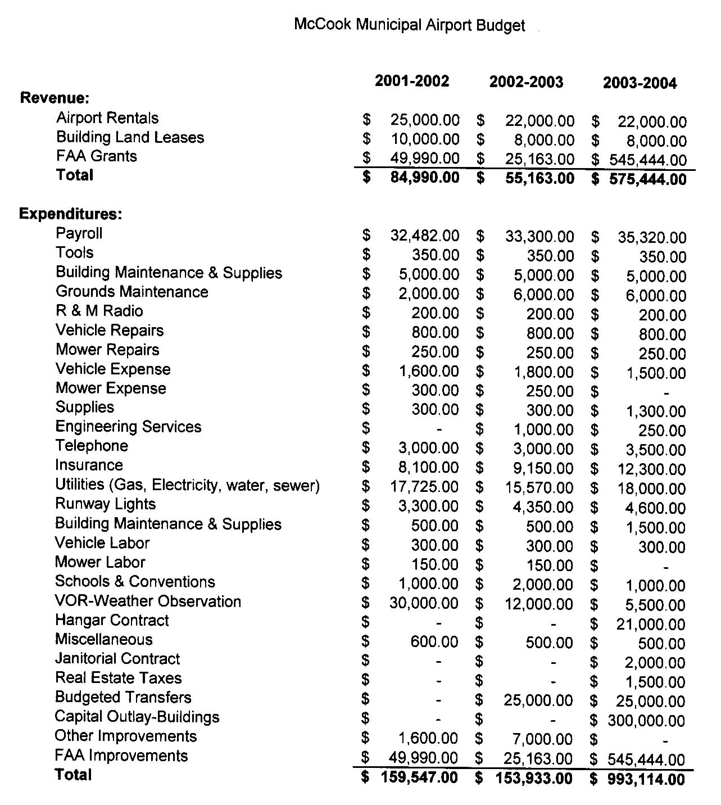
Great Lakes Airlines
North Platte/Denver Schedule
May 1, 2004

Arrivals
Mon-Fri | Central Time | Flight # | Originates
 | 12:49 PM | 5137 | Denver
 | 5:04 PM | 5135 | Denver
 | 8:54 PM | 5139 | Denver
Saturday | Central Time | Flight # | Originates
 | 12:49 PM | 5137 | Denver
 | 6:24 PM | 5139 | Denver
Sunday | Central Time | Flight # | Originates
 | 12:49 PM | 5137 | Denver
 | 8:54 PM | 5139 | Denver

Departures
Mon-Fri | Central Time | Flight # | Destination
 | 7:20 AM | 5134 | Denver
 | 1:10 PM | 5136 | Denver
 | 5:22 PM | 5138 | Denver
Saturday | Central Time | Flight # | Destination
 | 7:20 AM | 5134 | Denver
 | 1:10 PM | 5136 | Denver
Sunday | Central Time | Flight # | Destination
 | 7:50 AM | 5134 | Denver
 | 1:10 PM | 5136 | Denver

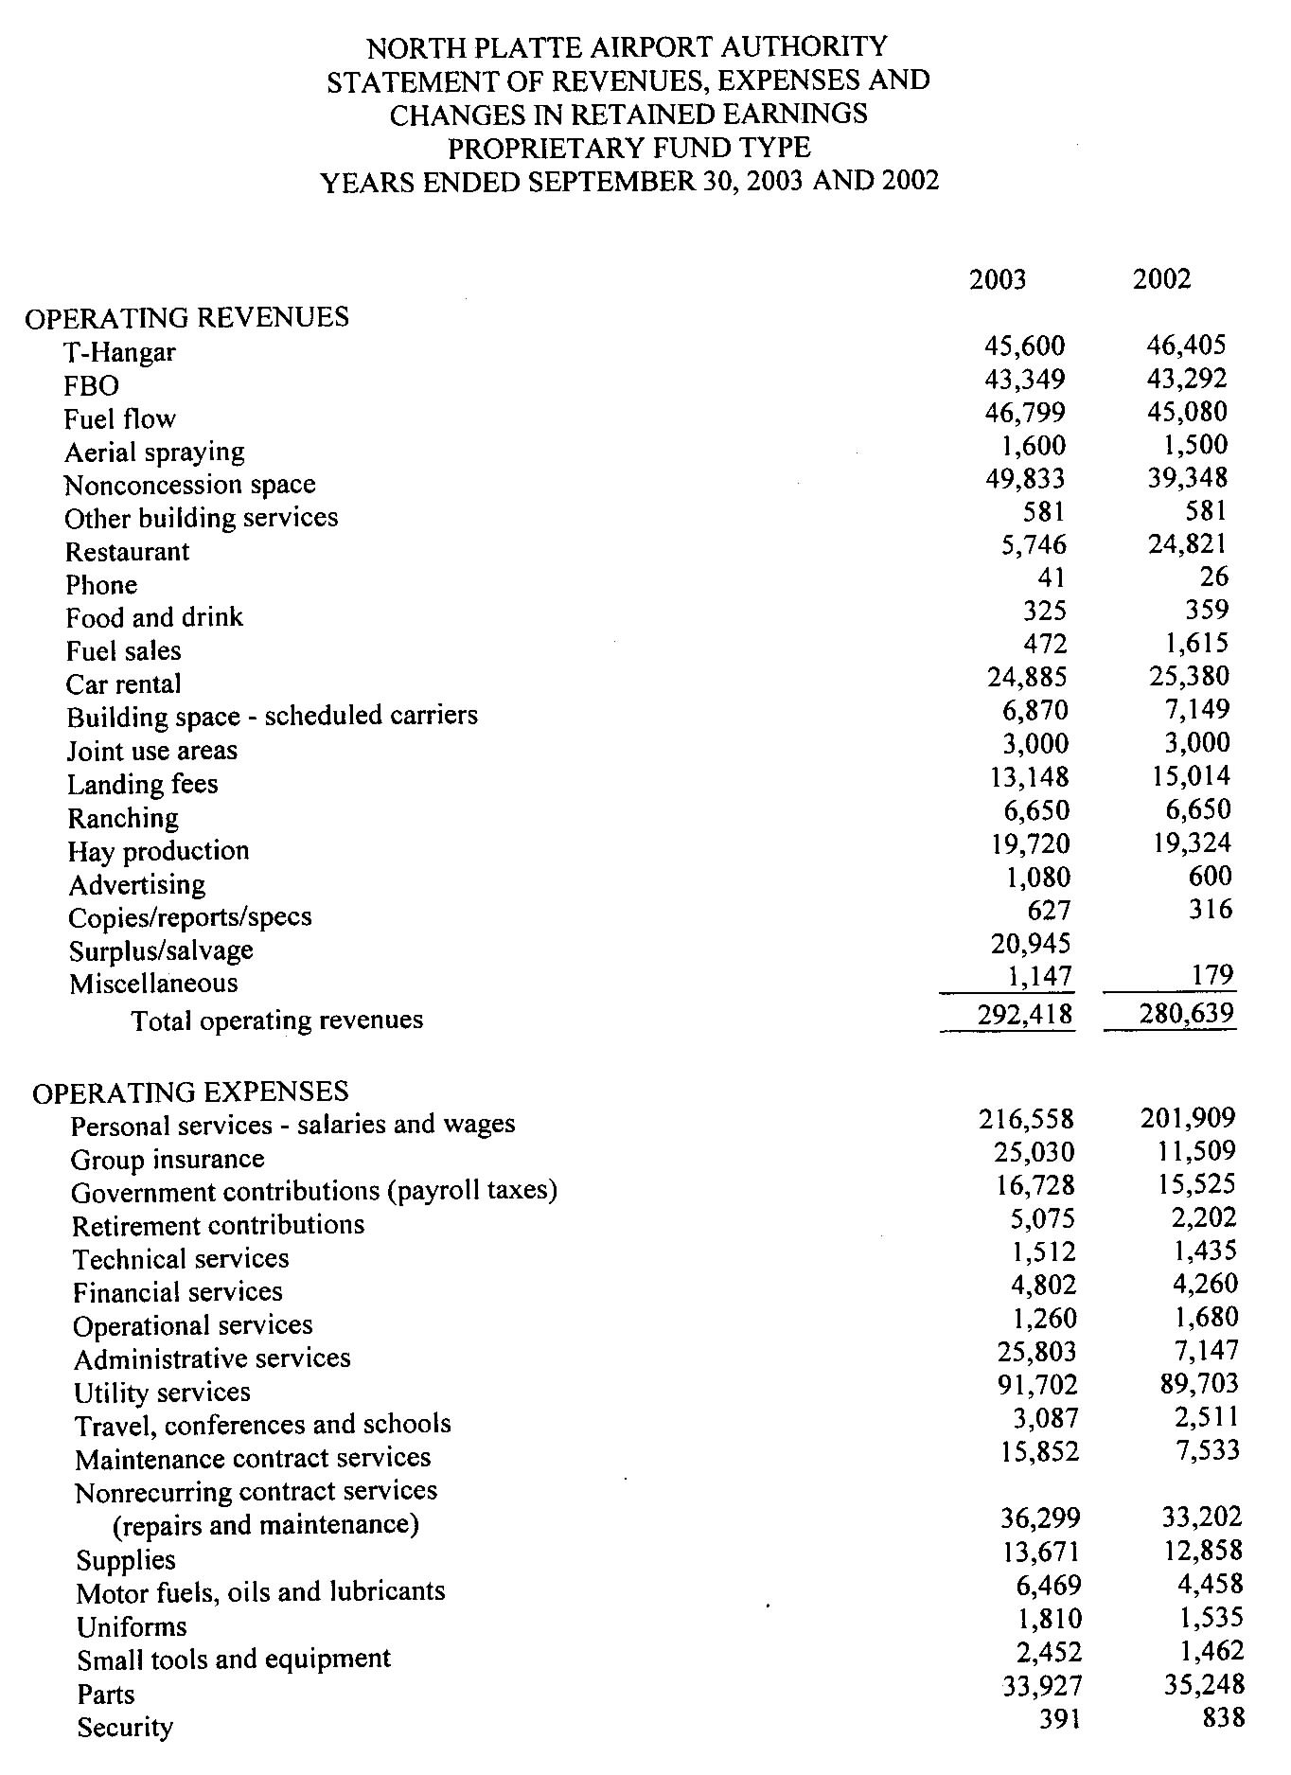
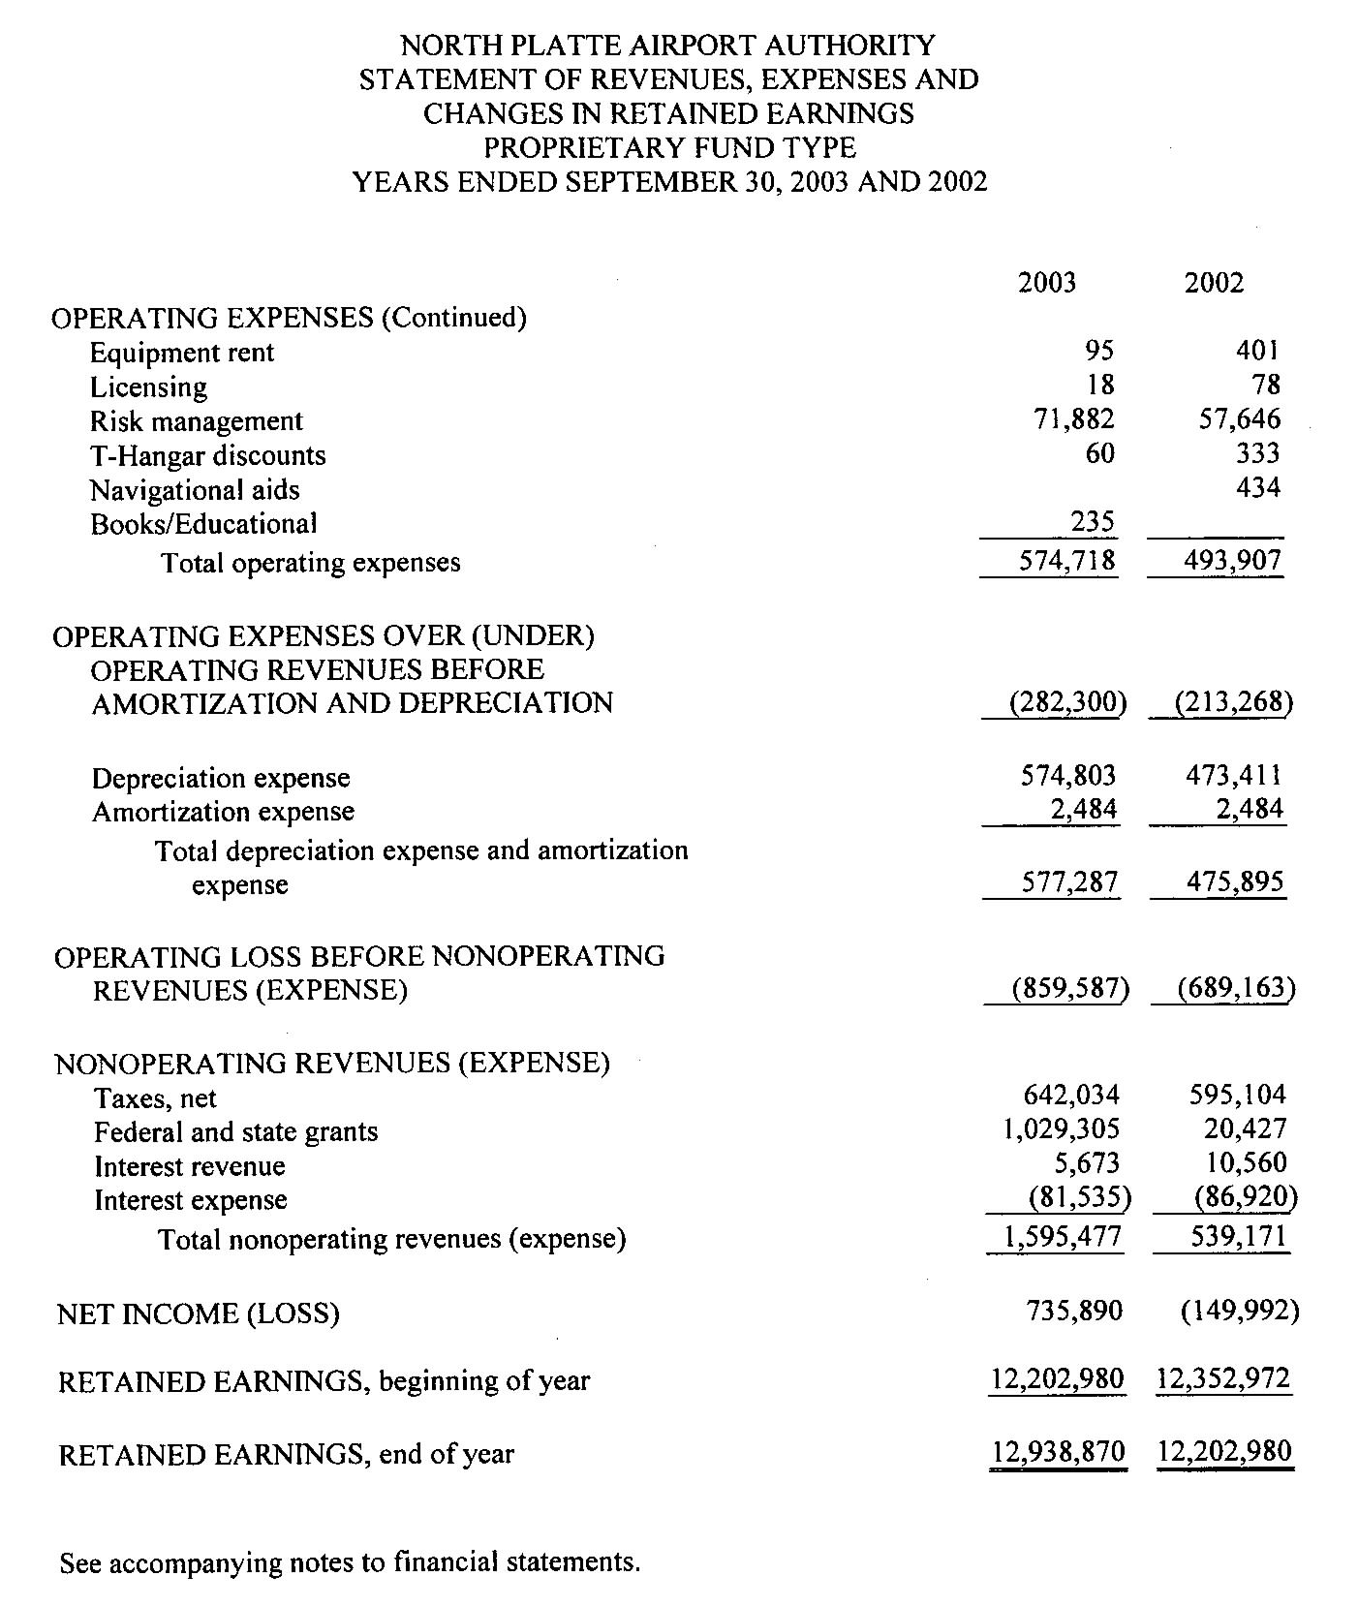
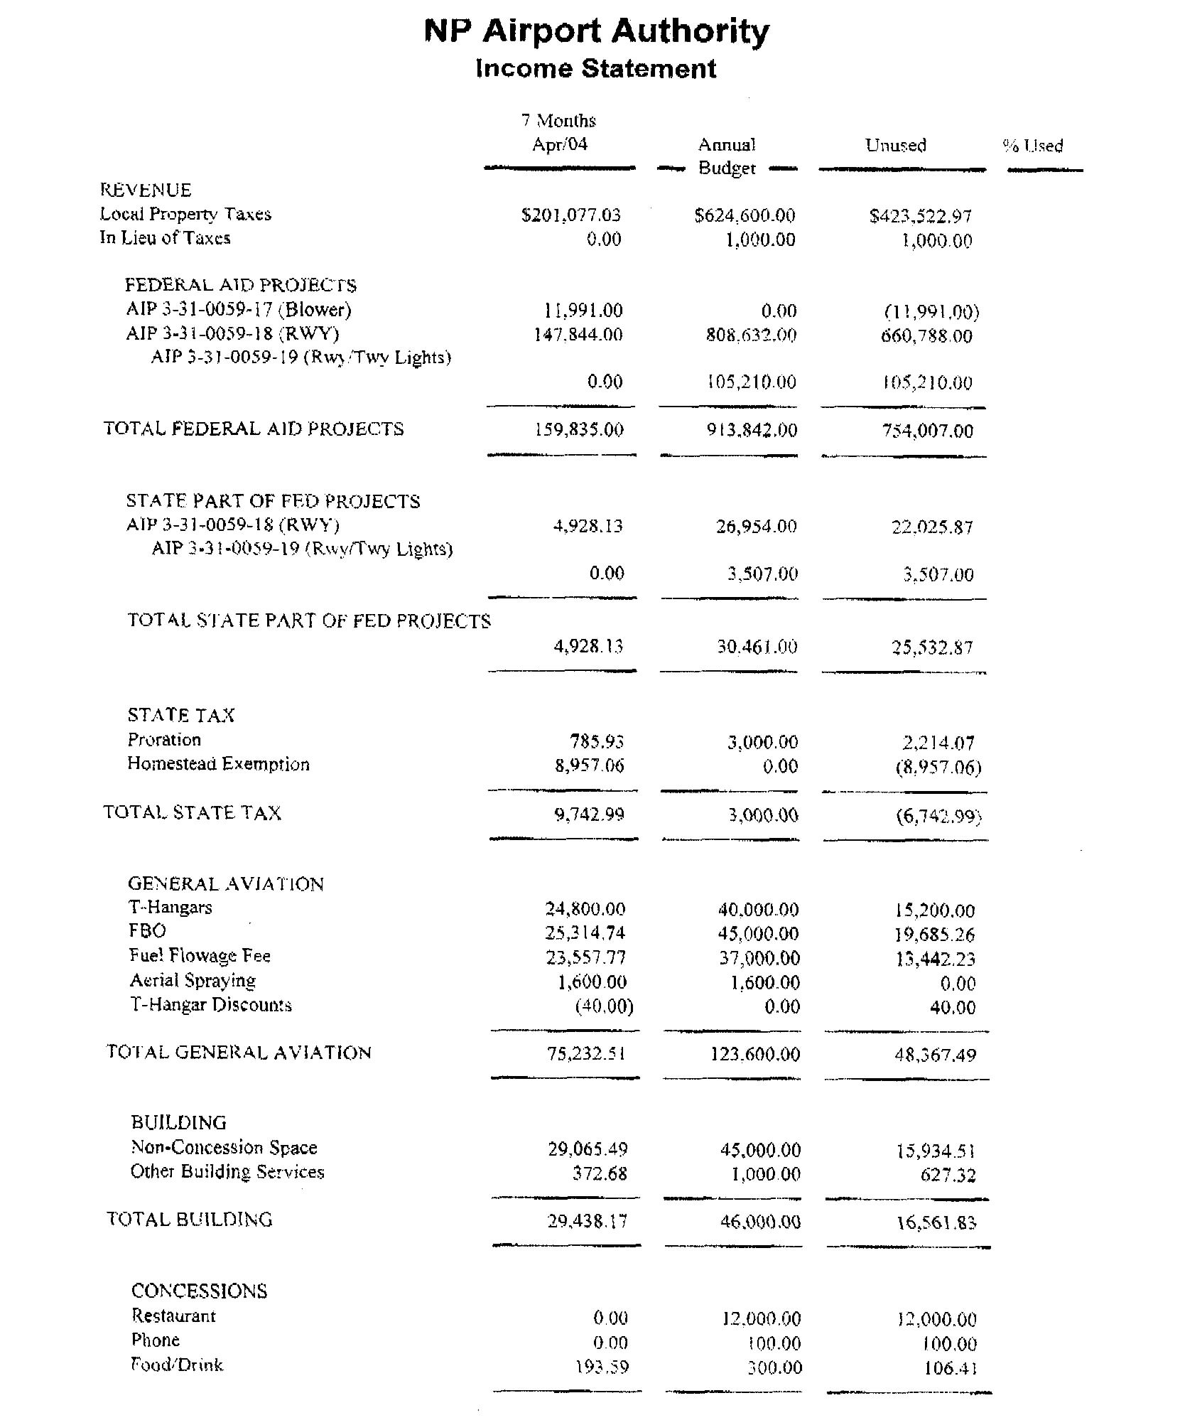
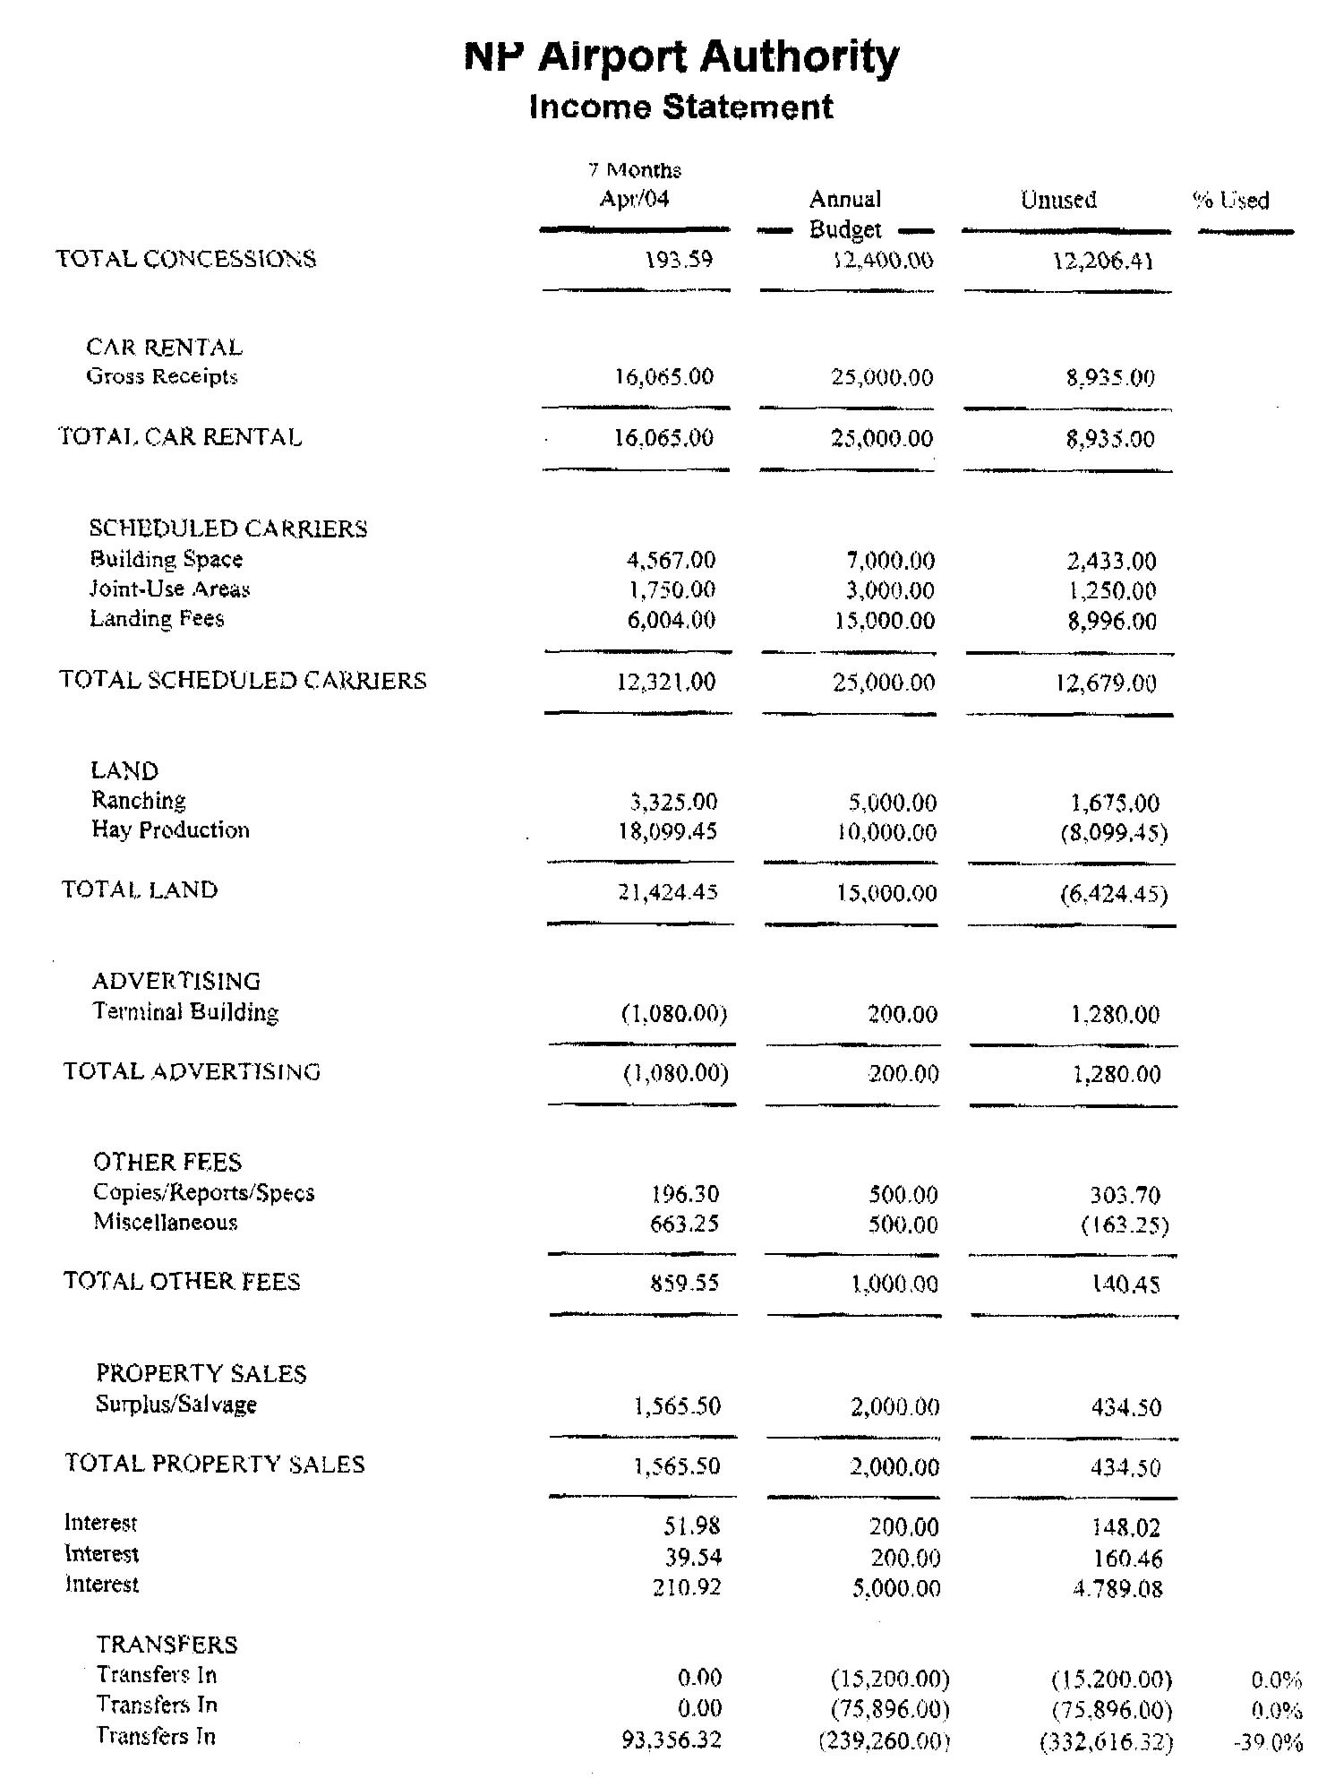

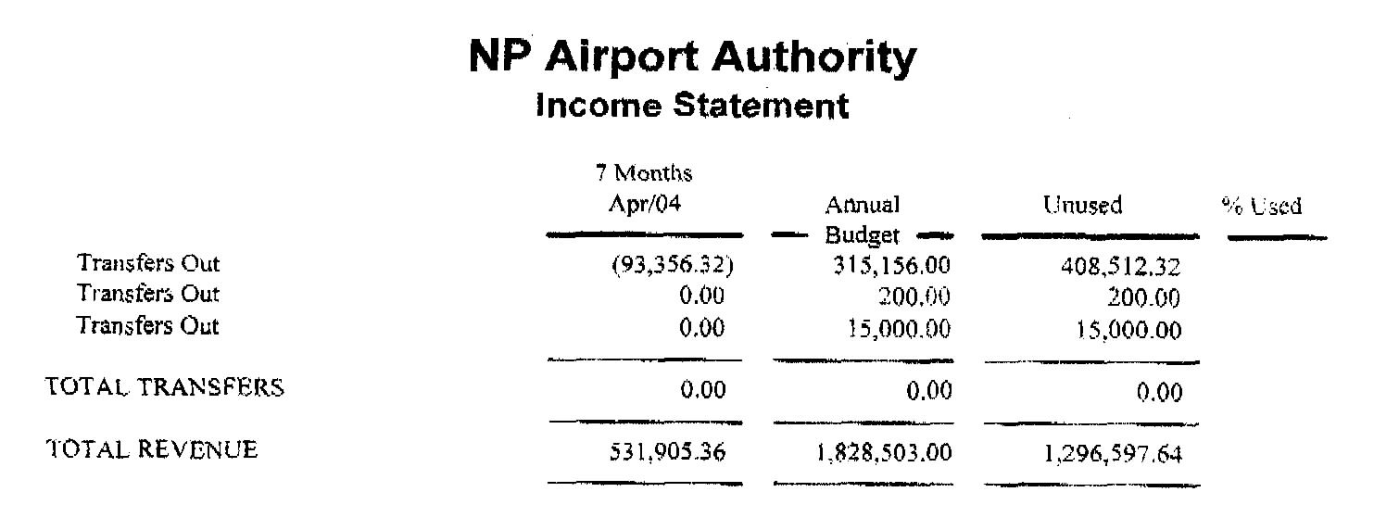
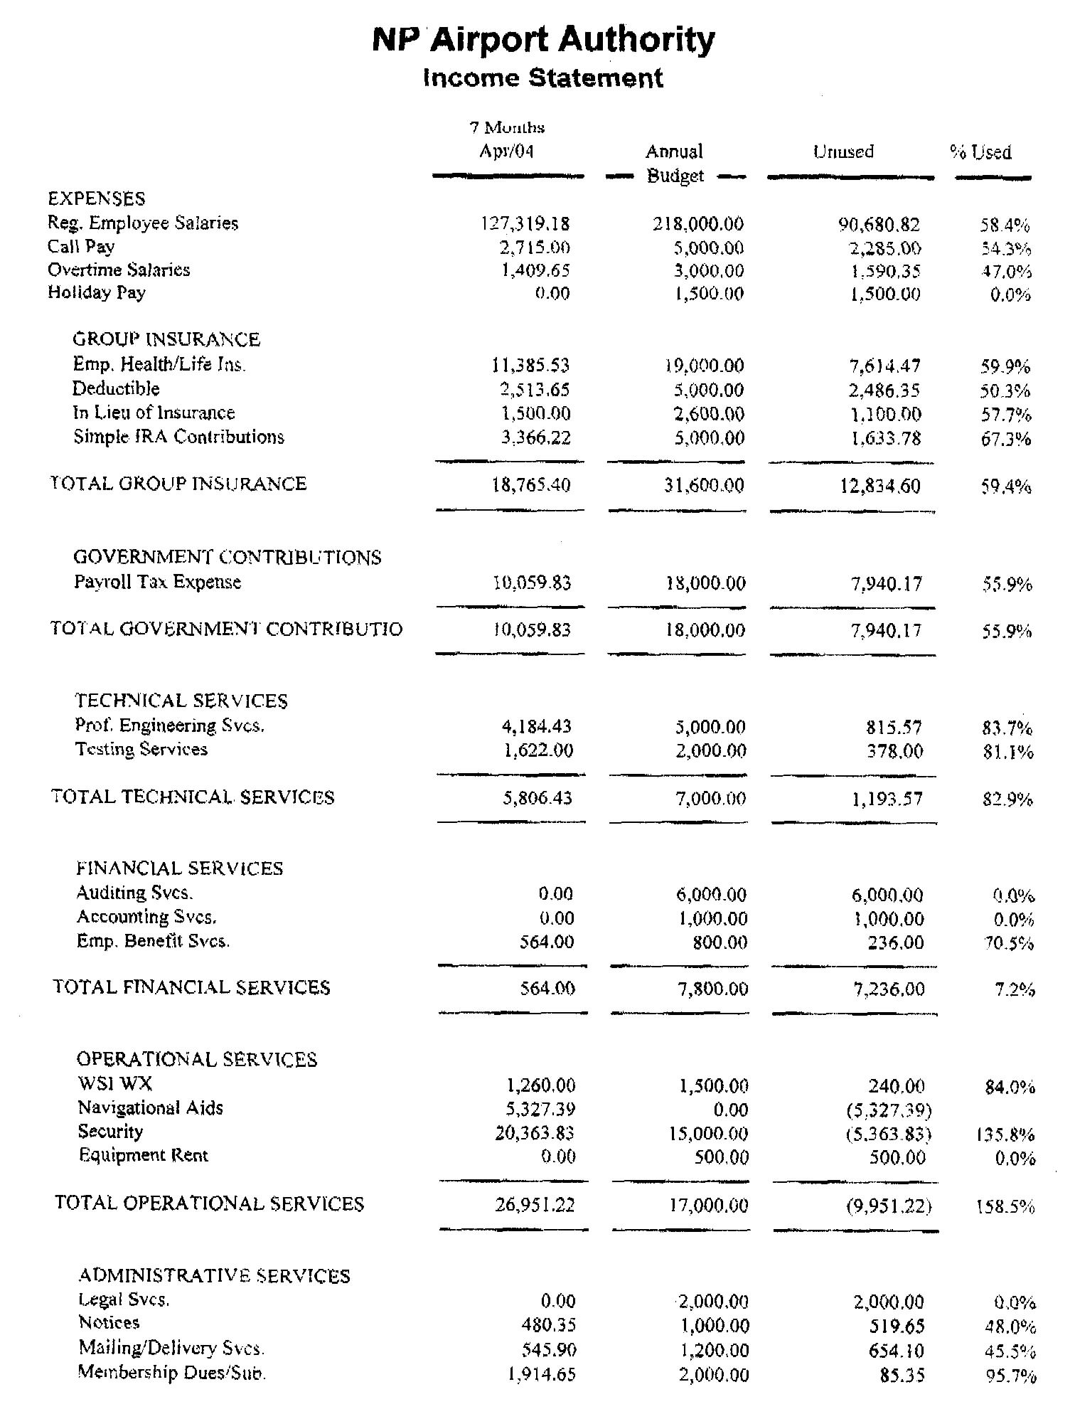
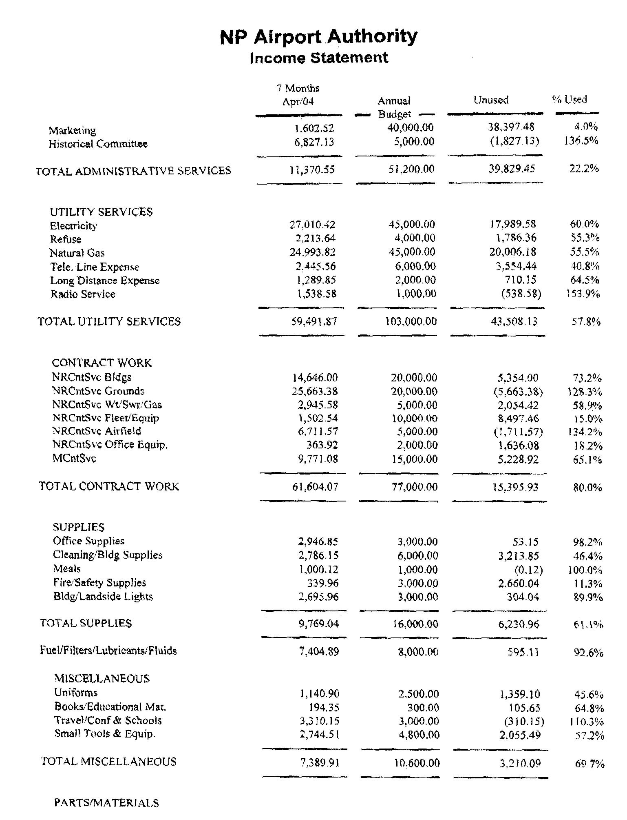

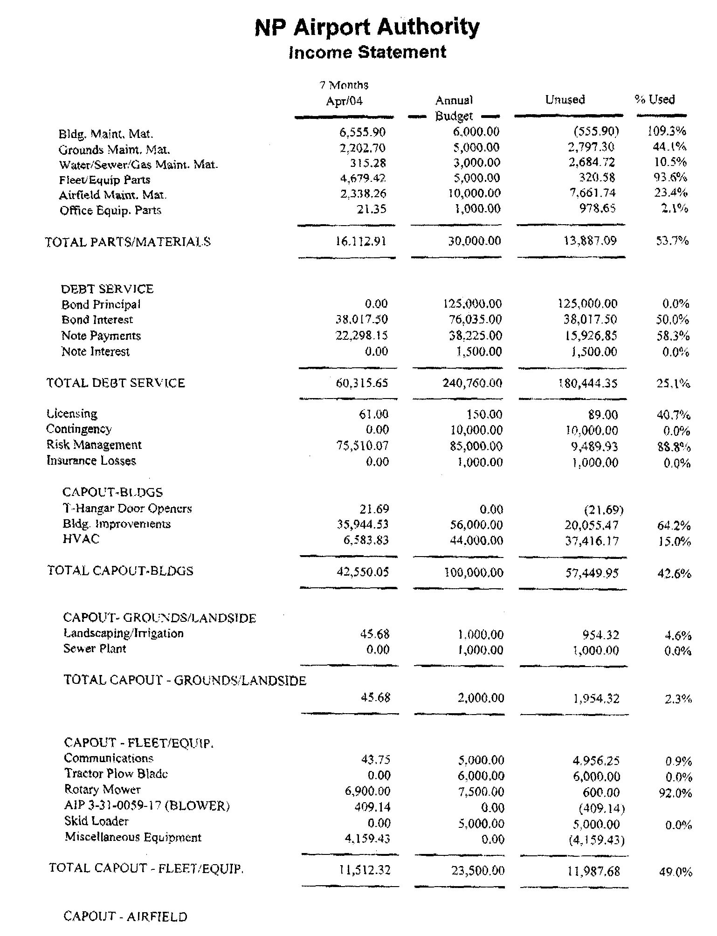

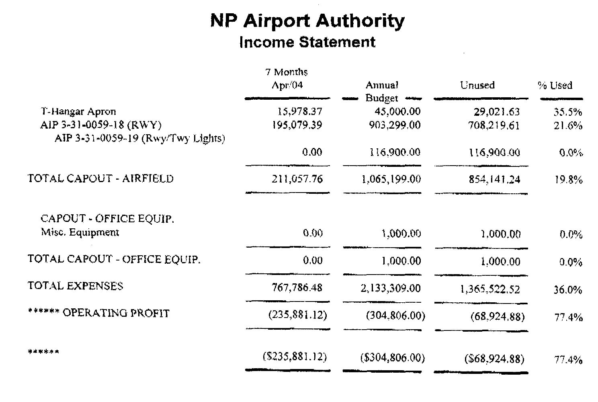

3. McCook/North Platte Schedules

Great Lakes Airlines
North Platte/Denver Schedule
May 1, 2004

Arrivals
Mon-Fri | Central Time | Flight # | Originates
 | 12:49 PM | 5137 | Denver
 | 5:04 PM | 5135 | Denver
 | 8:54 PM | 5139 | Denver
Saturday | Central Time | Flight # | Originates
 | 12:49 PM | 5137 | Denver
 | 6:24 PM | 5139 | Denver
Sunday | Central Time | Flight # | Originates
 | 12:49 PM | 5137 | Denver
 | 8:54 PM | 5139 | Denver

Departures
Mon-Fri | Central Time | Flight # | Destination
 | 7:20 AM | 5134 | Denver
 | 1:10 PM | 5136 | Denver
 | 5:22 PM | 5138 | Denver
Saturday | Central Time | Flight # | Destination
 | 7:20 AM | 5134 | Denver
 | 1:10 PM | 5136 | Denver
Sunday | Central Time | Flight # | Destination
 | 7:50 AM | 5134 | Denver
 | 1:10 PM | 5136 | Denver

Great Lakes Airlines
McCook/Denver Schedule
May 1, 2004

Arrivals
Mon-Fri | Central Time | Flight # | Originates
 | 11:01 AM | 5037 | Denver
 | 2:51 PM | 5023 | Denver
 | 9:31 PM | 5039 | Denver
Saturday | Central Time | Flight # | Originates
 | 6:11 PM | 5035 | Denver
Sunday | Central Time | Flight # | Originates
 | 3:16 PM | 5035 | Denver
 | 9:31 PM | 5039 | Denver

Departures
Mon-Fri | Central Time | Flight # | Destination
 | 7:44 AM | 5034 | Denver
 | 11:16 AM | 5038 | Denver
 | 4:54 PM | 5016 | Denver
Saturday | Central Time | Flight # | Destination
 | 7:44 AM | 5034 | Denver
Sunday | Central Time | Flight # | Destination
 | 10:15 AM | 5034 | Denver
 | 5:22 PM | 5036 | Denver

Great Lakes Airlines
McCook/Grand Island Schedule
May 1, 2004

Arrivals
Mon-Fri | Central Time | Flight # | Originates
 | 7:34 AM | 5034 | Grand Island
 | 4:44 PM | 5016 | Grand Island
Saturday | Central Time | Flight # | Originates
 | 6:50 AM | 5034 | Grand Island
Sunday | Central Time | Flight # | Originates
 | 10:04 AM | 5034 | Grand Island
 | 5:12 PM | 5036 | Grand Island

Departures
Mon-Fri | Central Time | Flight # | Destination
 | 3:01 PM | 5023 | Grand Island
 | 9:41 PM | 5039 | Grand Island
Saturday | Central Time | Flight # | Destination
 | 6:21 PM | 5035 | Grand Island
Sunday | Central Time | Flight # | Destination
 | 3:26 PM | 5035 | Grand Island
 | 9:41 PM | 5039 | Grand Island

Westward Airways Proposed River Run Schedule
 | Departs | Arrives | Stops
North Platte to Lincoln | 6:50 AM  5:50 PM | 7:45 AM  6:45 PM | Nonstop  Nonstop
North Platte to Omaha | 6:50 AM  5:50 PM | 8:20 AM  7:20 PM | 1 stop  1 stop
North Platte to Scottsbluff | 10:00 AM  9:00 PM | 9:45 AM (MST)  8:45 PM (MST) | Nonstop  Nonstop
Lincoln to North Platte | 9:00 AM  8:00 PM | 9:55 AM  8:55 PM | Nonstop  Nonstop
Omaha to North Platte | 8:25 AM  7:25 PM | 9:55 AM  8:55 PM | 1 stop  1 stop
Scottsbluff to  North Platte | 5:00 AM (MST)  4:00 PM (MST) | 6:45 AM  5:45 PM | Nonstop  Nonstop
North Platte Regional Airport

(Anticipate starting Summer 2004)

4. Enplanements
1983-1992
1993-2003
Enplanements (Boardings)

 | McCook | North Platte | Kearney | Alliance
2003 | 1,761 | 5,986 | 5,553 | 1,032
2002 | 1,815 | 5,989 | 5,184 | 873
2001 | 2,058 | 6,637 | 7,042 | 754
2000 | 2,454 | 9,017 | 10,463 | 1,346
1999 | 2,307 | 8,094 | 7,720 | 1,479
1998 | 2,744 | 10,089 | 5,513 | 1,827
1997 | 1,537 | 11,699 | 1,070 | 1,021
1996 | 886 | 10,016 | 917 | 619
1995 | 842 | 11,143 | 2,638 | 558
1994 | 1,070 | 13,536 | 3,362 | 616
1993 | 1,182 | 17,583 | 3,374 | 826
1992 | 1,170 | 16,396 | 3,200 | 969
1991 | 1,055 | 15,860 | 3,351 | 578
1990 | 1,074 | 14,496 | 3,419 | 764
1989 | 979 | 12,749 | 2,574 | 868
1988 | 1,264 | 14,850 | 2,751 | 848
1987 | 1,447 | 11,559 | 2,698 | 798
1986 | 4,197 | 11,167 | 1,087 | 894
1985 | 1,110 | 11,445 | 3,467 | 337
1984 | 3,112 | 12,785 | 1,603 | 1,396
1983 | 2,783 | 20,230 | 1,331 | 995
1983-2002 emplanements are official U.S. DOT numbers
2003 enplanements are reported by individual airports

5. Fare Comparisons
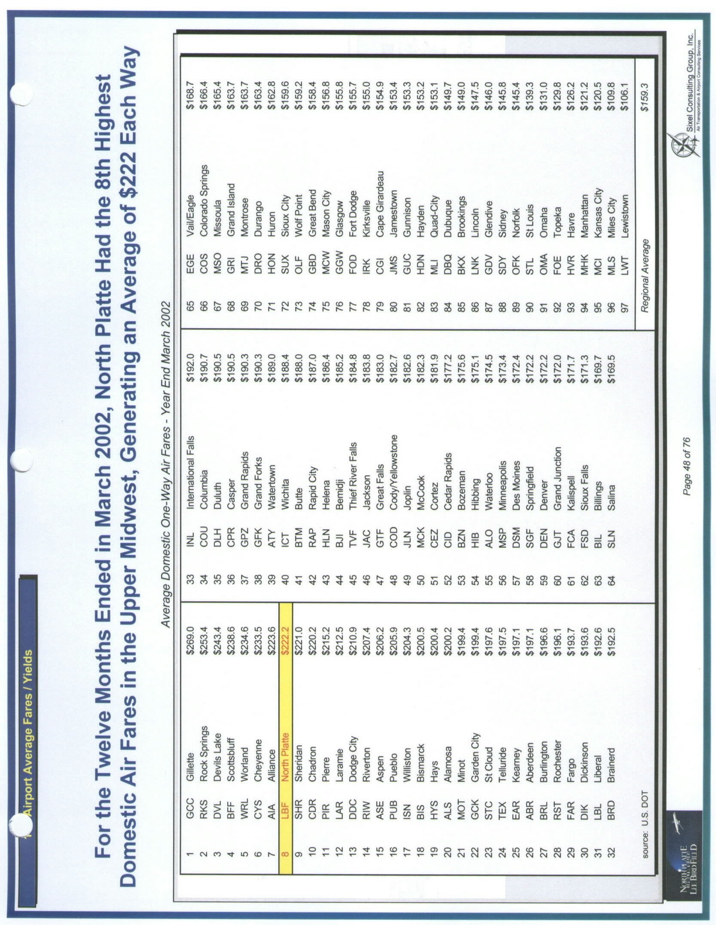
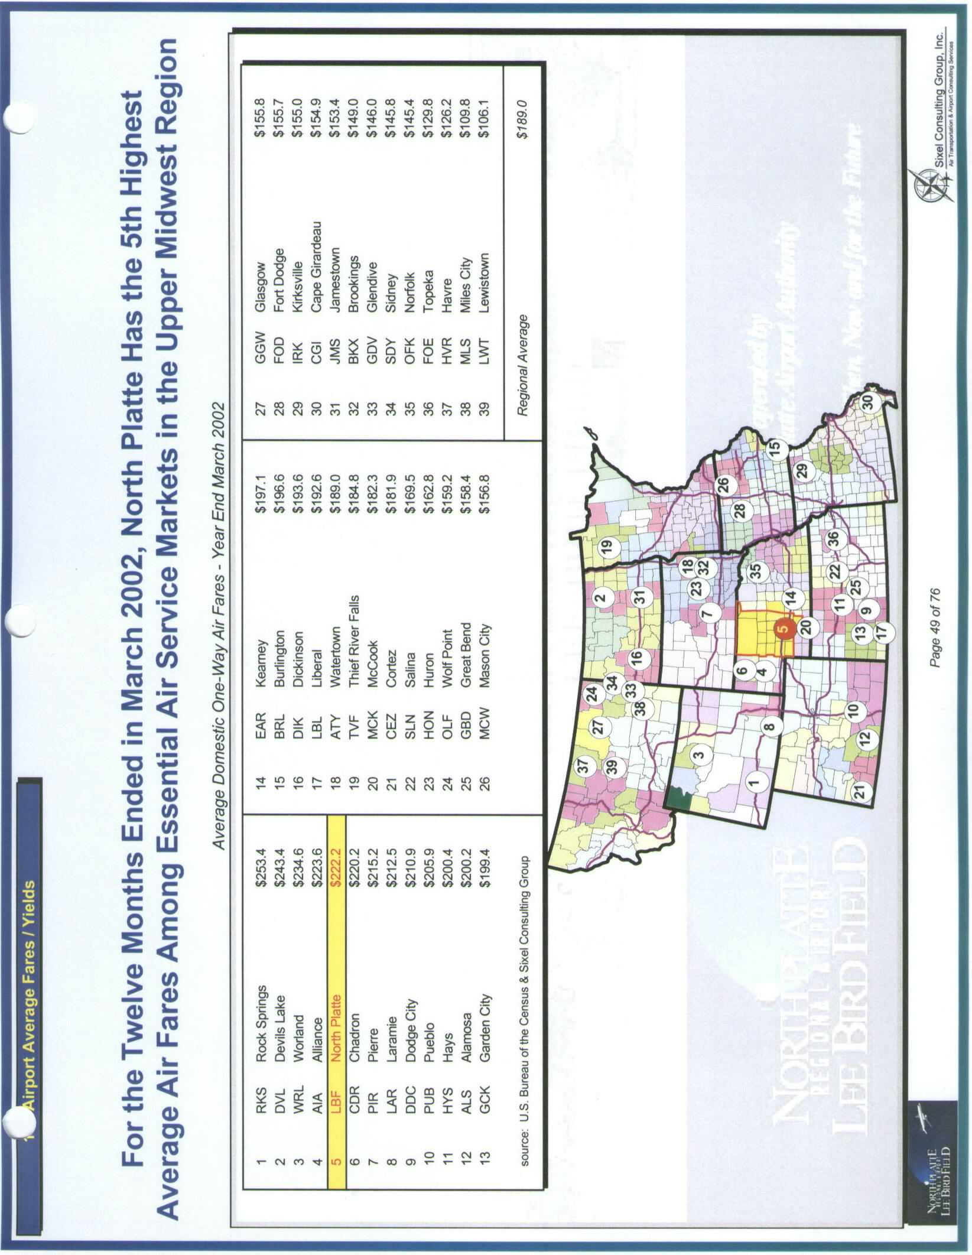




Top of Form
Please notice numbers 5300-5399 are FlightLink ground service operated by Greyhound
selected flights:
From: McCook, NE To: Denver, CO, Return: McCook, NE
Departure Date: Friday, May 21, 2004
Return Date: Sunday, May 23, 2004
Cabin: Coach, Number of Passengers: 1
Step 2: Choose your flight:
Departure | Price*
McCook, NE to Denver, CO  Flight 5016: Wednesday, May 19, 2004  Departs: 04:54 PM, Arrives: 04:55 PM  Cabin Coach | $92.00
McCook, NE to Denver, CO  Flight 5034: Thursday, May 20, 2004  Departs: 07:44 AM, Arrives: 07:47 AM  Cabin Coach | $92.00
McCook, NE to Denver, CO  Flight 5038: Thursday, May 20, 2004  Departs: 11:16 AM, Arrives: 11:19 AM  Cabin Coach | $92.00
McCook, NE to Denver, CO  Flight 5016: Thursday, May 20, 2004  Departs: 04:54 PM, Arrives: 04:55 PM  Cabin Coach | $92.00
McCook, NE to Denver, CO  Flight 5034: Friday, May 21, 2004  Departs: 07:44 AM, Arrives: 07:47 AM  Cabin Coach | $92.00
McCook, NE to Denver, CO  Flight 5038: Friday, May 21, 2004  Departs: 11:16 AM, Arrives: 11:19 AM  Cabin Coach | $92.00
McCook, NE to Denver, CO  Flight 5016: Friday, May 21, 2004  Departs: 04:54 PM, Arrives: 04:55 PM  Cabin Coach | $104.00
McCook, NE to Denver, CO  Flight 5034: Saturday, May 22, 2004  Departs: 07:44 AM, Arrives: 07:47 AM  Cabin Coach | $92.00
McCook, NE to Denver, CO  Flight 5034: Sunday, May 23, 2004  Departs: 10:15 AM, Arrives: 10:18 AM  Cabin Coach | $104.00
McCook, NE to Denver, CO  Flight 5036: Sunday, May 23, 2004  Departs: 05:22 PM, Arrives: 05:25 PM  Cabin Coach | $92.00
McCook, NE to Denver, CO  Flight 5034: Monday, May 24, 2004  Departs: 07:44 AM, Arrives: 07:47 AM  Cabin Coach | $92.00
Returning | Price*
Denver, CO to McCook, NE  Flight 5039: Thursday, May 20, 2004  Departs: 07:30 PM, Arrives: 09:31 PM  Cabin | $92.00
Denver, CO to McCook, NE  Flight 5037: Friday, May 21, 2004  Departs: 09:00 AM, Arrives: 11:01 AM  Cabin | $92.00
Denver, CO to McCook, NE  Flight 5023: Friday, May 21, 2004  Departs: 12:50 PM, Arrives: 02:51 PM  Cabin | $92.00
Denver, CO to McCook, NE  Flight 5039: Friday, May 21, 2004  Departs: 07:30 PM, Arrives: 09:31 PM  Cabin | $92.00
Denver, CO to McCook, NE  Flight 5035: Saturday, May 22, 2004  Departs: 04:10 PM, Arrives: 06:11 PM  Cabin | $92.00
Denver, CO to McCook, NE  Flight 5035: Sunday, May 23, 2004  Departs: 01:15 PM, Arrives: 03:16 PM  Cabin Coach | $104.00
Denver, CO to McCook, NE  Flight 5039: Sunday, May 23, 2004  Departs: 07:30 PM, Arrives: 09:31 PM  Cabin | $92.00
Denver, CO to McCook, NE  Flight 5037: Monday, May 24, 2004  Departs: 09:00 AM, Arrives: 11:01 AM  Cabin | $92.00
Denver, CO to McCook, NE  Flight 5023: Monday, May 24, 2004  Departs: 12:50 PM, Arrives: 02:51 PM  Cabin | $92.00
Denver, CO to McCook, NE  Flight 5039: Monday, May 24, 2004  Departs: 07:30 PM, Arrives: 09:31 PM  Cabin | $92.00
Denver, CO to McCook, NE  Flight 5037: Tuesday, May 25, 2004  Departs: 09:00 AM, Arrives: 11:01 AM  Cabin | $92.00

Top of Form
Please notice numbers 5300-5399 are FlightLink ground service operated by Greyhound
selected flights:
From: Kearney, NE To: Denver, CO, Return: Kearney, NE
Departure Date: Friday, May 21, 2004
Return Date: Sunday, May 23, 2004
Cabin: Coach, Number of Passengers: 1
Step 2: Choose your flight:
Departure | Price*
Kearney, NE to Denver, CO  Flight 5004: Wednesday, May 19, 2004  Departs: 06:30 PM, Arrives: 06:54 PM  Cabin Coach | $100.00
Kearney, NE to Denver, CO  Flight 5000: Thursday, May 20, 2004  Departs: 07:26 AM, Arrives: 07:50 AM  Cabin Coach | $100.00
Kearney, NE to Denver, CO  Flight 5002: Thursday, May 20, 2004  Departs: 01:07 PM, Arrives: 01:31 PM  Cabin Coach | $100.00
Kearney, NE to Denver, CO  Flight 5004: Thursday, May 20, 2004  Departs: 06:30 PM, Arrives: 06:54 PM  Cabin Coach | $100.00
Kearney, NE to Denver, CO  Flight 5000: Friday, May 21, 2004  Departs: 07:26 AM, Arrives: 07:50 AM  Cabin Coach | $100.00
Kearney, NE to Denver, CO  Flight 5002: Friday, May 21, 2004  Departs: 01:07 PM, Arrives: 01:31 PM  Cabin Coach | $100.00
Kearney, NE to Denver, CO  Flight 5004: Friday, May 21, 2004  Departs: 06:30 PM, Arrives: 06:54 PM  Cabin Coach | $100.00
Kearney, NE to Denver, CO  Flight 5000: Saturday, May 22, 2004  Departs: 07:26 AM, Arrives: 07:50 AM  Cabin Coach | $126.00
Kearney, NE to Denver, CO  Flight 5002: Saturday, May 22, 2004  Departs: 01:07 PM, Arrives: 01:31 PM  Cabin Coach | $113.00
Kearney, NE to Denver, CO  Flight 5000: Sunday, May 23, 2004  Departs: 07:26 AM, Arrives: 07:50 AM  Cabin Coach | $100.00
Kearney, NE to Denver, CO  Flight 5004: Sunday, May 23, 2004  Departs: 06:30 PM, Arrives: 06:54 PM  Cabin Coach | $100.00
Returning | Price*
Denver, CO to Kearney, NE  Flight 5001: Friday, May 21, 2004  Departs: 10:35 AM, Arrives: 12:52 PM  Cabin | $100.00
Denver, CO to Kearney, NE  Flight 5003: Friday, May 21, 2004  Departs: 03:55 PM, Arrives: 06:11 PM  Cabin | $100.00
Denver, CO to Kearney, NE  Flight 5005: Friday, May 21, 2004  Departs: 06:50 PM, Arrives: 09:06 PM  Cabin | $100.00
Denver, CO to Kearney, NE  Flight 5001: Saturday, May 22, 2004  Departs: 09:25 AM, Arrives: 11:41 AM  Cabin | $100.00
Denver, CO to Kearney, NE  Flight 5005: Saturday, May 22, 2004  Departs: 06:50 PM, Arrives: 09:06 PM  Cabin Coach | $113.00
Denver, CO to Kearney, NE  Flight 5003: Sunday, May 23, 2004  Departs: 03:55 PM, Arrives: 06:11 PM  Cabin | $100.00
Denver, CO to Kearney, NE  Flight 5005: Sunday, May 23, 2004  Departs: 06:50 PM, Arrives: 09:06 PM  Cabin | $100.00
Denver, CO to Kearney, NE  Flight 5001: Monday, May 24, 2004  Departs: 10:35 AM, Arrives: 12:52 PM  Cabin | $100.00
Denver, CO to Kearney, NE  Flight 5003: Monday, May 24, 2004  Departs: 03:55 PM, Arrives: 06:11 PM  Cabin | $126.00
Denver, CO to Kearney, NE  Flight 5005: Monday, May 24, 2004  Departs: 06:50 PM, Arrives: 09:06 PM  Cabin | $100.00
Denver, CO to Kearney, NE  Flight 5001: Tuesday, May 25, 2004  Departs: 10:35 AM, Arrives: 12:52 PM  Cabin | $100.00

Top of Form
Please notice numbers 5300-5399 are FlightLink ground service operated by Greyhound
selected flights:
From: North Platte, NE To: Denver, CO, Return: North Platte, NE
Departure Date: Friday, May 21, 2004
Return Date: Sunday, May 23, 2004
Cabin: Coach, Number of Passengers: 1
Step 2: Choose your flight:
Departure | Price*
North Platte, NE to Denver, CO  Flight 5138: Wednesday, May 19, 2004  Departs: 05:22 PM, Arrives: 05:30 PM  Cabin Coach | $93.00
North Platte, NE to Denver, CO  Flight 5134: Thursday, May 20, 2004  Departs: 07:20 AM, Arrives: 07:28 AM  Cabin Coach | $105.00
North Platte, NE to Denver, CO  Flight 5136: Thursday, May 20, 2004  Departs: 01:10 PM, Arrives: 01:18 PM  Cabin Coach | $93.00
North Platte, NE to Denver, CO  Flight 5138: Thursday, May 20, 2004  Departs: 05:22 PM, Arrives: 05:30 PM  Cabin Coach | $93.00
North Platte, NE to Denver, CO  Flight 5134: Friday, May 21, 2004  Departs: 07:20 AM, Arrives: 07:28 AM  Cabin Coach | $93.00
North Platte, NE to Denver, CO  Flight 5136: Friday, May 21, 2004  Departs: 01:10 PM, Arrives: 01:18 PM  Cabin Coach | $93.00
North Platte, NE to Denver, CO  Flight 5138: Friday, May 21, 2004  Departs: 05:22 PM, Arrives: 05:30 PM  Cabin Coach | $93.00
North Platte, NE to Denver, CO  Flight 5134: Saturday, May 22, 2004  Departs: 07:20 AM, Arrives: 07:28 AM  Cabin Coach | $93.00
North Platte, NE to Denver, CO  Flight 5136: Saturday, May 22, 2004  Departs: 01:10 PM, Arrives: 01:18 PM  Cabin Coach | $93.00
North Platte, NE to Denver, CO  Flight 5134: Sunday, May 23, 2004  Departs: 07:50 AM, Arrives: 07:58 AM  Cabin Coach | $93.00
North Platte, NE to Denver, CO  Flight 5136: Sunday, May 23, 2004  Departs: 01:10 PM, Arrives: 01:18 PM  Cabin Coach | $93.00
Returning | Price*
Denver, CO to North Platte, NE  Flight 5137: Friday, May 21, 2004  Departs: 10:45 AM, Arrives: 12:49 PM  Cabin | $93.00
Denver, CO to North Platte, NE  Flight 5135: Friday, May 21, 2004  Departs: 03:00 PM, Arrives: 05:04 PM  Cabin | $93.00
Denver, CO to North Platte, NE  Flight 5139: Friday, May 21, 2004  Departs: 06:50 PM, Arrives: 08:54 PM  Cabin | $93.00
Denver, CO to North Platte, NE  Flight 5137: Saturday, May 22, 2004  Departs: 10:45 AM, Arrives: 12:49 PM  Cabin | $93.00
Denver, CO to North Platte, NE  Flight 5139: Saturday, May 22, 2004  Departs: 04:40 PM, Arrives: 06:44 PM  Cabin | $93.00
Denver, CO to North Platte, NE  Flight 5137: Sunday, May 23, 2004  Departs: 10:45 AM, Arrives: 12:49 PM  Cabin | $93.00
Denver, CO to North Platte, NE  Flight 5139: Sunday, May 23, 2004  Departs: 06:50 PM, Arrives: 08:54 PM  Cabin | $93.00
Denver, CO to North Platte, NE  Flight 5137: Monday, May 24, 2004  Departs: 10:45 AM, Arrives: 12:49 PM  Cabin | $93.00
Denver, CO to North Platte, NE  Flight 5135: Monday, May 24, 2004  Departs: 03:00 PM, Arrives: 05:04 PM  Cabin | $93.00
Denver, CO to North Platte, NE  Flight 5139: Monday, May 24, 2004  Departs: 06:50 PM, Arrives: 08:54 PM  Cabin | $93.00
Denver, CO to North Platte, NE  Flight 5137: Tuesday, May 25, 2004  Departs: 10:45 AM, Arrives: 12:49 PM  Cabin | $93.00

Top of Form
Please notice numbers 5300-5399 are FlightLink ground service operated by Greyhound
selected flights:
From: Alliance, NE To: Denver, CO, Return: Alliance, NE
Departure Date: Friday, May 21, 2004
Return Date: Sunday, May 23, 2004
Cabin: Coach, Number of Passengers: 1
Step 2: Choose your flight:
Departure | Price*
Alliance, NE to Denver, CO  Flight 5114: Tuesday, May 18, 2004  Departs: 01:34 PM, Arrives: 02:30 PM  Cabin Coach | $101.00
Alliance, NE to Denver, CO  Flight 5012: Wednesday, May 19, 2004  Departs: 06:54 AM, Arrives: 07:50 AM  Cabin Coach | $89.00
Alliance, NE to Denver, CO  Flight 5114: Wednesday, May 19, 2004  Departs: 01:34 PM, Arrives: 02:30 PM  Cabin Coach | $89.00
Alliance, NE to Denver, CO  Flight 5012: Thursday, May 20, 2004  Departs: 06:54 AM, Arrives: 07:50 AM  Cabin Coach | $89.00
Alliance, NE to Denver, CO  Flight 5114: Thursday, May 20, 2004  Departs: 01:34 PM, Arrives: 02:30 PM  Cabin Coach | $89.00
Alliance, NE to Denver, CO  Flight 5012: Friday, May 21, 2004  Departs: 06:54 AM, Arrives: 07:50 AM  Cabin Coach | $89.00
Alliance, NE to Denver, CO  Flight 5114: Friday, May 21, 2004  Departs: 01:34 PM, Arrives: 02:30 PM  Cabin Coach | $89.00
Alliance, NE to Denver, CO  Flight 5012: Saturday, May 22, 2004  Departs: 06:54 AM, Arrives: 07:50 AM  Cabin Coach | $89.00
Alliance, NE to Denver, CO  Flight 5114: Sunday, May 23, 2004  Departs: 01:34 PM, Arrives: 02:30 PM  Cabin Coach | $89.00
Alliance, NE to Denver, CO  Flight 5012: Monday, May 24, 2004  Departs: 06:54 AM, Arrives: 07:50 AM  Cabin Coach | $89.00
Alliance, NE to Denver, CO  Flight 5114: Monday, May 24, 2004  Departs: 01:34 PM, Arrives: 02:30 PM  Cabin Coach | $89.00
Returning | Price*
Denver, CO to Alliance, NE  Flight 5114: Thursday, May 20, 2004  Departs: 11:34 AM, Arrives: 01:24 PM  Cabin | $89.00
Denver, CO to Alliance, NE  Flight 5027: Thursday, May 20, 2004  Departs: 06:45 PM, Arrives: 07:40 PM  Cabin | $89.00
Denver, CO to Alliance, NE  Flight 5114: Friday, May 21, 2004  Departs: 11:34 AM, Arrives: 01:24 PM  Cabin | $89.00
Denver, CO to Alliance, NE  Flight 5027: Friday, May 21, 2004  Departs: 06:45 PM, Arrives: 07:40 PM  Cabin | $89.00
Denver, CO to Alliance, NE  Flight 5114: Saturday, May 22, 2004  Departs: 12:37 PM, Arrives: 01:32 PM  Cabin | $89.00
Denver, CO to Alliance, NE  Flight 5027: Sunday, May 23, 2004  Departs: 06:45 PM, Arrives: 07:40 PM  Cabin | $89.00
Denver, CO to Alliance, NE  Flight 5114: Monday, May 24, 2004  Departs: 11:34 AM, Arrives: 01:24 PM  Cabin | $89.00
Denver, CO to Alliance, NE  Flight 5027: Monday, May 24, 2004  Departs: 06:45 PM, Arrives: 07:40 PM  Cabin | $89.00
Denver, CO to Alliance, NE  Flight 5114: Tuesday, May 25, 2004  Departs: 11:34 AM, Arrives: 01:24 PM  Cabin | $89.00
Denver, CO to Alliance, NE  Flight 5027: Tuesday, May 25, 2004  Departs: 06:45 PM, Arrives: 07:40 PM  Cabin | $89.00
Denver, CO to Alliance, NE  Flight 5114: Wednesday, May 26, 2004  Departs: 11:34 AM, Arrives: 01:24 PM  Cabin | $89.00

McCook, NE (MCK) to Orlando, FL (MCO)
When you combine the 12 outbound and 11 return flights for this route you have 132 possible roundtrips.
Close

  non stop
  1 stop
  2+ stops
  All Results
  from $589
  from $515
  Great Lakes Airlines
  from $652
  from $515
  United Airlines
  from $659
  from $515
  Frontier Airlines
  from $589
  US Airways
  from $610
  Northwest
  from $716

Note: The prices shown below are e-ticket prices and include all taxes and fees. If your itinerary requires paper tickets there will be an additional charge.
1 Choose a departing flight | View results by:

Sort by: Price Shortest flights Departure time Arrival time

from $515 Roundtrip
7:44 am Depart McCook (MCK)  Arrive Orlando (MCO) 5:59 pm | Fri 21-May  Duration: 9hr 15mn
  Great Lakes Airlines 5034
  United Airlines 2244 / 2870
  Connect in Denver (Denver Intl.), Philadelphia (Philadelphia Intl.)
Choose this departure

from $534 Roundtrip
7:44 am Depart McCook (MCK)  Arrive Orlando (MCO) 4:10 pm | Fri 21-May  Duration: 7hr 26mn
  Frontier Airlines 5034 / 672
  Connect in Denver (Denver Intl.)
Choose this departure

from $591 Roundtrip
11:16 am Depart McCook (MCK)  Arrive Orlando (MCO) 8:40 pm | Fri 21-May  Duration: 8hr 24mn
  Great Lakes Airlines 5038
  Frontier Airlines 674
  Connect in Denver (Denver Intl.)
Choose this departure

from $594 Roundtrip
7:44 am Depart McCook (MCK)  Arrive Orlando (MCO) 1:53 pm | Fri 21-May  Duration: 5hr 9mn
  United Airlines 5034 / 1420
  Connect in Denver (Denver Intl.)
Choose this departure

from $602 Roundtrip
7:44 am Depart McCook (MCK)  Arrive Orlando (MCO) 5:59 pm | Fri 21-May  Duration: 9hr 15mn
  United Airlines 5034 / 2244 / 2870
  Connect in Denver (Denver Intl.), Philadelphia (Philadelphia Intl.)
Choose this departure

from $610 Roundtrip
11:16 am Depart McCook (MCK)  Arrive Orlando (MCO) 9:44 pm | Fri 21-May  Duration: 9hr 28mn
  Great Lakes Airlines 5038
  US Airways 120 / 1448
  Connect in Denver (Denver Intl.), Charlotte (CLT)
Choose this departure

from $615 Roundtrip
7:44 am Depart McCook (MCK)  Arrive Orlando (MCO) 5:59 pm | Fri 21-May  Duration: 9hr 15mn
  Great Lakes Airlines 5034
  US Airways 140 / 1157
  Connect in Denver (Denver Intl.), Philadelphia (Philadelphia Intl.)
Choose this departure

from $620 Roundtrip
7:44 am Depart McCook (MCK)  Arrive Orlando (MCO) 4:10 pm | Fri 21-May  Duration: 7hr 26mn
  Great Lakes Airlines 5034
  Frontier Airlines 672
  Connect in Denver (Denver Intl.)
Choose this departure

from $634 Roundtrip
4:54 pm Depart McCook (MCK)  Arrive Orlando (MCO) 11:52 pm | Fri 21-May  Duration: 5hr 58mn
  Great Lakes Airlines 5016
  United Airlines 1426
  Connect in Denver (Denver Intl.)
Choose this departure

from $665 Roundtrip
4:54 pm Depart McCook (MCK)  Arrive Orlando (MCO) 11:52 pm | Fri 21-May  Duration: 5hr 58mn
  Great Lakes Airlines 5016
  US Airways 7310
  Connect in Denver (Denver Intl.)
Choose this departure

from $665 Roundtrip
4:54 pm Depart McCook (MCK)  Arrive Orlando (MCO) 12:46 am +1 day | Fri 21-May  Duration: 6hr 52mn
  Great Lakes Airlines 5016
  Delta 664 / 875
  Connect in Denver (Denver Intl.), Atlanta (Hartsfield Intl.)
Choose this departure

from $716 Roundtrip
7:44 am Depart McCook (MCK)  Arrive Orlando (MCO) 4:41 pm | Fri 21-May  Duration: 7hr 57mn
  Great Lakes Airlines 5034
  Northwest 822 / 956
  Connect in Denver (Denver Intl.), Memphis (MEM)
Choose this departure

North Platte, NE (LBF) to Orlando, FL (MCO)
When you combine the 15 outbound and 6 return flights for this route you have 90 possible roundtrips.
Close

  non stop
  1 stop
  2+ stops
  All Results
  from $576
  from $545
  United Airlines
  from $576
  from $576
  Great Lakes Airlines
  from $660
  from $588
  US Airways
  from $730
  from $609
  Frontier Airlines
  from $628
  Northwest
  from $718

Note: The prices shown below are e-ticket prices and include all taxes and fees. If your itinerary requires paper tickets there will be an additional charge.
1 Choose a departing flight | View results by:

Sort by: Price Shortest flights Departure time Arrival time

from $545 Roundtrip
1:10 pm Depart North Platte (LBF)  Arrive Orlando (MCO) 8:40 pm | Fri 21-May  Duration: 6hr 30mn
  Frontier Airlines 5136 / 674
  Connect in Denver (Denver Intl.)
Choose this departure

from $558 Roundtrip
7:20 am Depart North Platte (LBF)  Arrive Orlando (MCO) 4:10 pm | Fri 21-May  Duration: 7hr 50mn
  Frontier Airlines 5134 / 672
  Connect in Denver (Denver Intl.)
Choose this departure

from $576 Roundtrip
1:10 pm Depart North Platte (LBF)  Arrive Orlando (MCO) 9:10 pm | Fri 21-May  Duration: 7hr 0mn
  United Airlines 5136 / 1424
  Connect in Denver (Denver Intl.)
Choose this departure

from $576 Roundtrip
1:10 pm Depart North Platte (LBF)  Arrive Orlando (MCO) 10:55 pm | Fri 21-May  Duration: 8hr 45mn
  Great Lakes Airlines 5136
  United Airlines 250 / 1108
  Connect in Denver (Denver Intl.), Chicago (ORD)
Choose this departure

from $580 Roundtrip
7:20 am Depart North Platte (LBF)  Arrive Orlando (MCO) 5:59 pm | Fri 21-May  Duration: 9hr 39mn
  Great Lakes Airlines 5134
  United Airlines 2244 / 2870
  Connect in Denver (Denver Intl.), Philadelphia (Philadelphia Intl.)
Choose this departure

from $583 Roundtrip
1:10 pm Depart North Platte (LBF)  Arrive Orlando (MCO) 10:55 pm | Fri 21-May  Duration: 8hr 45mn
  United Airlines 5136 / 250 / 1108
  Connect in Denver (Denver Intl.), Chicago (ORD)
Choose this departure

from $583 Roundtrip
1:10 pm Depart North Platte (LBF)  Arrive Orlando (MCO) 11:44 pm | Fri 21-May  Duration: 9hr 34mn
  United Airlines 5136 / 554 / 1569
  Connect in Denver (Denver Intl.), Washington DC (IAD)
Choose this departure

from $596 Roundtrip
1:10 pm Depart North Platte (LBF)  Arrive Orlando (MCO) 8:40 pm | Fri 21-May  Duration: 6hr 30mn
  Great Lakes Airlines 5136
  Frontier Airlines 674
  Connect in Denver (Denver Intl.)
Choose this departure

from $609 Roundtrip
1:10 pm Depart North Platte (LBF)  Arrive Orlando (MCO) 9:44 pm | Fri 21-May  Duration: 7hr 34mn
  Great Lakes Airlines 5136
  US Airways 120 / 1448
  Connect in Denver (Denver Intl.), Charlotte (CLT)
Choose this departure

from $628 Roundtrip
7:20 am Depart North Platte (LBF)  Arrive Orlando (MCO) 1:53 pm | Fri 21-May  Duration: 5hr 33mn
  United Airlines 5134 / 1420
  Connect in Denver (Denver Intl.)
Choose this departure

from $628 Roundtrip
5:22 pm Depart North Platte (LBF)  Arrive Orlando (MCO) 11:52 pm | Fri 21-May  Duration: 5hr 30mn
  United Airlines 5138 / 1426
  Connect in Denver (Denver Intl.)
Choose this departure

6. Department of Aeronautics Capital Improvement Program
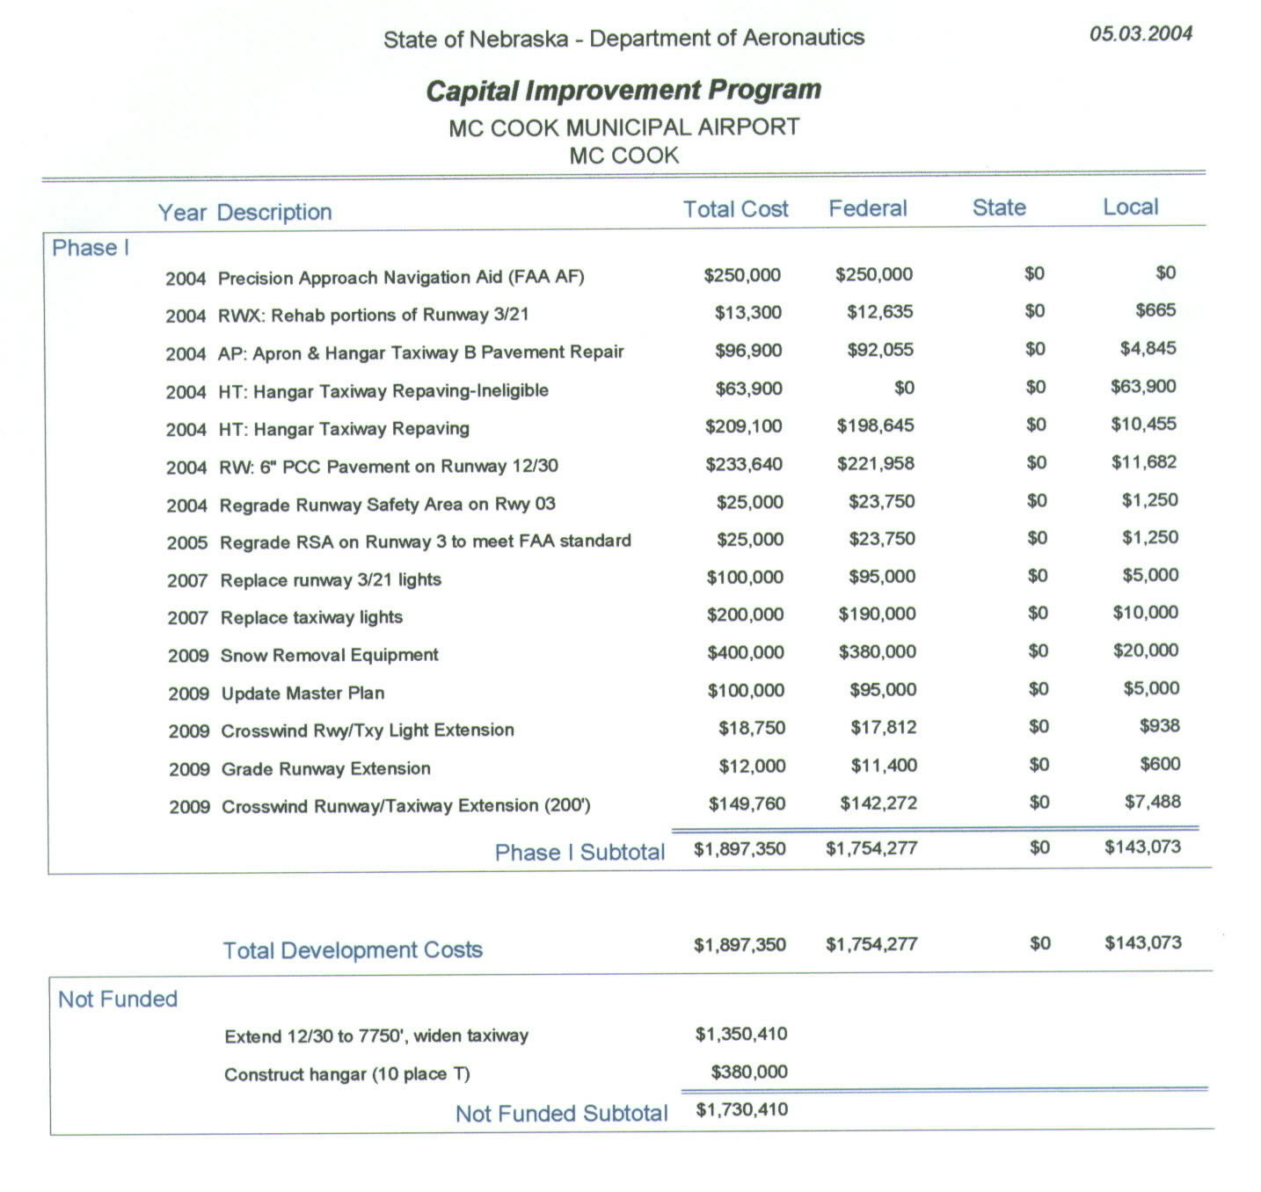

7. Letters of Support


