PROPOSAL UNDER THE SMALL COMMUNITY AIR SERVICE DEVELOPMENT PROGRAM

DOCKET-OST-2006-23671

Gogebic/Iron County Airport

Legal Sponsor: Gogebic/Iron County Airport
Ironwood, MI 49938
DUNS Number 122718435
Table of Contents

Section I: Existing Air Service
Section II: Historical Air Service
Section III: Community Air Service Deficiencies
Section IV: Strategic Planning
Section V: Partnerships
Section VI: Proposal Funding
Section VII: Monitoring of the Program
Section VIII: Program Sustainability
Section IX: Air Service Development
Section X: Legal Sponsor
Additions:
Appendix B- Summary Information
Attachments:
- Gogebic/Iron County Airport Passenger Enplanements Data
- Michigan Department of Transportation - Aeronautics division study
- Five Year Development Plan (Prepared by Mead Hunt)
- Gogebic/Iron County Airport Board Members

2
The Gogebic/Iron County Airport Board is submitting this proposal to the Small Community Air Service Development Program (SCASDP), in order to offer the incumbent carrier (Midwest Connect) a financial incentive to add an additional direct flight to Milwaukee daily.

Section I: Existing Air Service

In January 2003, Midwest Connect began providing service to the Gogebic/Iron County Airport. Currently Midwest Connect provides 13 flights per week and the schedule breakdown is as follows:

Arrivals:

Monday through Friday Flight 1031 - 1:13 PM Flight 1035 - 11:40 PM

Saturday Flight 1031 - 1:13 PM Flight 1637 - 5:15 PM

Sunday Flight 1035 - 11:40 PM

Departures:

Monday through Friday Flight 1030 - 5:20 AM Flight 1032 - 1:23 PM

Saturday Flight 1030 - 5:20 AM Flight 1032 - 1:23 PM

Sunday Flight 1031 - 1:23 PM

All flights are routed through Milwaukee, Wisconsin, after making a brief stop in Rhinelander, Wisconsin. General Mitchell International Airport is the hub for Midwest Airlines, which features nonstop jet service to major destinations throughout the United States.

Midwest Connect currently services the Gogebic/Iron County Airport with the Beechcraft 1900 D-model turboprop aircraft, with a seating capacity of 19 passengers.

Section II: Historical Air Service

The Gogebic/Iron County Airport has a history of commercial airline service going back 66 years. The historical timetable is as follows:

- 1939: Ironwood, Michigan receives its first commercial flight, with service provided by Wisconsin Central Airlines.

- 1979-1983: Republic Airlines began to provide commercial air service at the Gogebic/Iron County Airport, with passenger enplanements ranging from a high of 11,796, to a low of 5,158. The aircraft utilized during this time was the DC 9 and Convair 580.
3

- 1984-1988: Simmons Airlines took over commercial air service. Passenger ridership varied from 3,723 to 2,363.

- 1989-2000: Great Lakes Airlines acquired the essential air service contract to keep our community linked to the air transportation service network.

Great Lakes Airlines began their service extremely aggressively, and provided the Gogebic/Iron County Airport traveler with a variety of destinations and frequency of flights that had never been provided. Because of this fact, passenger boardings began to once again show growth; the first-year ridership rose to 2,559. In year two, passengers who flew Great Lakes Airlines out of the Gogebic/Iron County Airport grew an incredible 71%, increasing to 4,398. Over the subsequent three years, passenger enplanements continued to grow until 1993 when a peak of 4,870 was reached. From the inception of Great Lakes Airlines providing service, the boarding of passengers at the Gogebic/Iron County Airport had risen an astonishing 90%. This incredible increase in ridership only demonstrates the possibilities and potential that the Gogebic/Iron County Airport is capable of.

In 1994, Great Lakes Airlines began to reduce the frequency of flights offered, which resulted in a 6% decrease in both departures and arrivals. This movement continued, with 1995-96 showing a 40% reduction in flights, which resulted in a 42% drop in passenger boardings. Over the next three years the passenger enplanements stabilized at approximately 2,075 persons per year. Great Lakes Airlines final year at the Gogebic/Iron County Airport once again decreased to a final number of 1,556 passenger enplanements.

While providing commercial air service at the Gogebic/Iron County Airport, Great Lakes Airlines operated as an independent, as well as providing service as a United Express carrier. By providing service to such major hubs as Chicago O'Hare International Airport and Minneapolis International Airport, as well as smaller markets such as Lansing, Michigan and Duluth, Minnesota, the airline should have continued to prosper. As Great Lakes began to reduce flights, the loss of passenger enplanements at the Gogebic/Iron County Airport began to increase as consumers began to lose confidence in this Airlines ability to provide reliable flights and dependable connections.

- 2003-Present: Midwest Connect was awarded the essential air service contract to provide air service to the Gogebic/Iron County Airport. Shortly after Midwest Connect began service passenger enplanements began to rise. In 2003 passenger enplanements increased to 2,272; 2004 increased to 2,816 and 2005 increased to 3,288 enplanements. (Attachment I)
4

Over the last three years, the Gogebic/Iron County Airport has regained the confidence of the business and leisure traveling public. The Airport Board strongly believes that by continuing this partnership with Midwest Connect, we can continue to recapture our lost market share; this may also help increase our community’s ability to develop more economic opportunities.
4

Section III: Community Air Service Deficiencies
The Gogebic/Iron County Airport Board, as well as the surrounding community, firmly believes that our current airline service is inadequate in regard to frequency of arrivals and departures. As stated previously, Midwest Connect provides only two inbound/outbound flights Monday through Saturday and Sunday only one inbound/outbound flight to the Gogebic/Iron County Airport. Currently all flights are direct to Milwaukee, they make a brief stop in Rhinelander, Wisconsin, where additional passengers are boarded. With this additional leg added to Ironwood's flight, there is direct competition for all available seats traveling to Milwaukee. This restricts our traveling public to the availability of all fares on this flight.

According to Michigan Department of Transportation - Aeronautics division study (Attachment II) “With only two weekday one-stop flights to Milwaukee, the current levels of leakage in Ironwood will continue at the rate of 80%. Because of the better frequency and higher number of consumer choices from Duluth, MN and Wausau, WI, there is virtually no chance of reducing this leakage without the addition of more service at Ironwood”.

We believe that if the passenger enplanements do not increase significantly at the Gogebic/Iron County Airport, we are in danger of losing our essential air service, which could possibly lead to discontuation of commercial airline service. This, in turn, would affect our airport funding to continue updating and maintaining the facilities. The rippling effect of this loss could have an extremely damaging effect on local businesses that rely on the airport’s ability to provide dependable year-round access to the nation’s air transportation network.

In looking at the results of the Michigan DOT study, it becomes clear that the demand for more service at the Gogebic/Iron County Airport is not being furnished. By providing an additional flight at the airport we are confident that the leakage can be reduced and the additional flight will rapidly become self-sustaining. Currently Gogebic/Iron County Airport residents are forced to commute to surrounding airports with commercial airline service due to the deficiency in available seats out of Ironwood. This adds an inconvenience of a four-hour minimum round-trip drive to the next nearest commercial airport; also the one-hour prior to flight minimum check in time would need to be taken into consideration. According to Michigan's five-year enplanements forecast dated December 2005, Northwest Airlines, Michigan's largest air carrier provider, anticipates reducing its capacity 15 to 17% in accordance with their bankruptcy restructuring efforts. With this possible loss of air service to our region, in relation to Northwest Airlines and their feeders, the Gogebic/Iron County Airport Board believes that Midwest Connect will have an influx of previous Northwest airline customers attempting to utilize their flights.

5
Section IV: Strategic Planning

The Gogebic/Iron County Airport Board has completed a Five Year Development Plan that was prepared by the engineering firm of Mead and Hunt (see Attachment III). Although the plan is sound, it was prepared for infrastructure and equipment improvements, not actual improvements to commercial air service. Because of that fact, and because Midwest Connect Airlines desires to wait until monies are obtained before negotiations take place, any future planning efforts associated with this proposal must be kept flexible. The money requested by the airport is substantial, yet it is also a worst-case scenario proposal. The $700,000 that we have requested from the Small Community Air Service Development Program would be utilized to add one additional flight per day. The proposal is for one year, but monies requested would cover the cost of the flight if not one seat was booked. This being the case, the Gogebic/Iron County Airport Board would ask that if funded, our proposal be allowed to run the maximum of three years or when all funding is exhausted, whichever occurs first. We feel very confident that our traveling public would utilize this flight.
5

The Gogebic/Iron County Airport has also looked at a realistic timetable to begin to implement our proposal. If awarded, this grant would utilize the timetable as follows:

- September 16, 2006 - Funding is awarded.
- October 2, 2006 - The negotiations with Midwest Connect will begin on increasing level of air service.

- October 16, 2006 - The marketing campaign begins. The breakdown for this campaign will be discussed in detail later in this proposal.

- November 20, 2006 - The new air service begins. With the onset of winter and the holiday season, we believe this would be an ideal time for an additional flight to startup.

- November 20, 2007 - one year from the programs inception (and funds expended), the Gogebic/Iron County Airport Board will review the numbers, and adjust the plan. Any changes (including extensions), will be brought back to the Small Community Program for approval.

As one can deduce, the plan must remain flexible until October 16 2007. At that time, we will have sound passenger data, as well as the amount of funding that has been expended. We are confident that the new service will become self-sufficient as the amount of leakage to other areas is dramatically reduced.

The marketing associated with this Proposal will be intense and diverse. The Gogebic/Iron County Airport will utilize both direct and indirect marketing, including billboard advertising with the “Fly From Nearby” slogan. Direct marketing efforts will include personal visits to major industries, governmental agencies, and educational facilities within our passenger catch area. With donated advertising by both local the newspaper and radio stations, we will also be able to promote the new service to a broad and diverse group. By being creative, yet focused, the promotion of the expanded service will get into the hands of the potential customer. With the exception of the billboard, monies will not be spent with the scattered approach, hoping that if the market is flooded with mailings, one customer may be obtained. We will focus on previous customers, as well as potential customers with a direct, informative campaign.
6
6

Section V: Partnerships

The Gogebic/Iron County Airport Board (see Attachment IV) is a partnership that not only crosses municipal boundaries, but also state lines. Both Gogebic County, Michigan and Iron County, Wisconsin operate the airport under a Joint Operating Agreement. These two counties have come to understand how vital it is for cooperation among governing bodies for economic growth.

The community is also strongly in favor of this Proposal, as demonstrated in the community support. In a rural area such as ours, the business community and citizens at large understand what an important component to the local economy the Gogebic/Iron County Airport is. In reviewing our package, we would ask that considerable weight be given to the amount of community support that has been demonstrated. With a population of fewer than 25,000 persons, the support offer by the businesses and residents of both Gogebic and Iron County is astonishing. Many of these financial contributions were given by businesses and individuals that do not directly use the commercial airline service; they realize the potential financial paybacks of reliable commercial airline service.

Section VI: Proposal Funding

The funding for this Proposal breaks down as follows:

Small Community Air Service Development Program - $700,000

Local Cash Commitments - $14,700

Airport In Kind - $2737.50

Local In Kind - $6,250

Total Funding $723,687.50

The commitments to the funding, other then what is being requested from SCASDP, can be found in letters of support which will be coming under separate cover from individual supporters.

7
Section VII: Monitoring of the Program

The Proposal that we are submitting is for one year, and the funding requested will be utilized to offset the cost of an additional daily flight at the Gogebic/Iron County Airport. It is a primary goal of those who operate the Airport to strive to make this flight self-sufficient. As stated in the proposed timeline, one year after the expending of the funds begins, the Gogebic/Iron County Airport Board will review the program and decide if it is attracting an increasing number of passengers, or if the overall number of enplanements at the airport remained flat.
7

Upon a thorough audit and review, the program will be honestly evaluated on its economic viability (we are confident that it will be). The Gogebic/Iron County Airport Board solemnly believes in fiscal responsibility at all levels of government. If it is determined that we are not moving toward an objective of self-sufficiency, the program will be discontinued.

Section VIII: Program Sustainability

It is the ultimate goal of those who operate the airport that the additional flight that we are proposing eventually will become self-sufficient. Although our request ($700,000) is for one of operation, that amount would be expended only if there were zero payments over the year. As we completely believe, that will not be the case. Because of this fact, we will once again requests that we be allowed to expend the monies (if granted) for up to three years (if favorably accepted). The program will be audited at the end of each year of operation, in order to determine if the numbers show its viability.

Additionally, as the baby boomers retire, we have realized an increase in the number of second homes in our area, as well as people moving “back home”. The area in which we are located has a large tourism based economy that is growing every year. We see this market as continuing to expand, and to this point, not one that has been fully tapped. The Gogebic/Iron County Airport market area also contains colleges, hospitals, light manufacturing, casinos, ski and golf resorts, rivers, trails, forests and the world's largest freshwater lake. With amenities within our market, we believe that an additional flight will move toward self-sufficiency fairly quickly.

Section IX: Air Service Development

Gogebic County, Michigan and Iron County, Wisconsin currently operate the Gogebic/Iron County Airport jointly. We would expect this partnership to exist, and thrive, well into the future.

The Gogebic/Iron County Airport Board is committed to aggressively marketing our Proposal, and developing a long-range plan to ensure the economic viability of our Airport. We know that as a trend of people escaping the city continues, our area is poised for major growth. The Gogebic/Iron County Airport Board, as well as the community involved, is committed to not only this Proposal, but also long-term sustainability of one of the area's most valuable economic development tool, the Gogebic/Iron County Airport. The previous five years, the Gogebic/Iron County Airport has aggressively promoted the use of their Airport facilities and the commercial airline provider. In conjunction with the State of Michigan, the Airport has spent $90,000 in advertising and promotional media. The Gogebic/Iron County Airport Board plans to remain active in continuing marketing efforts of any air carrier that may utilize our airport.
8
8

Section X: Legal Sponsor

The legal sponsor of the proposal is the Gogebic/Iron County Airport, Ironwood Michigan.

Contact Information:

Pat Merrill, Director
Gogebic County Economic Development Commission
E 4946 Jackson Rd.
Ironwood, Michigan 49938
(906) 932-2090

OR

Duane R. DuRay, Airport Manager
Gogebic/Iron County Airport
E5560 Airport Road
Ironwood, Michigan 49938
(906) 932-3121
9

APPENDIX B

10
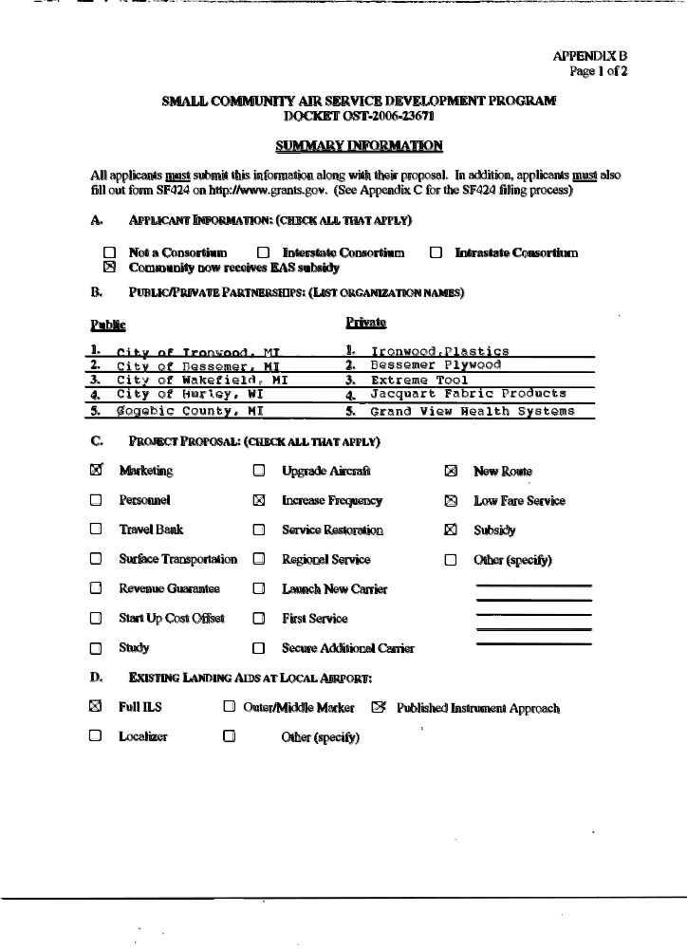
11
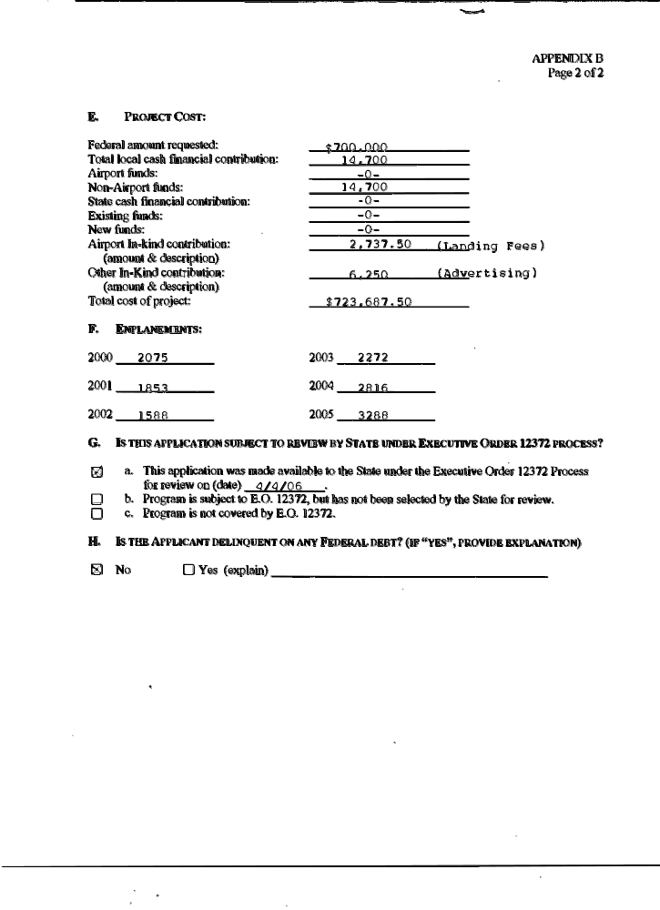
12
ATTACHMENTS:

I, II, III, and IV
13

Attachment I

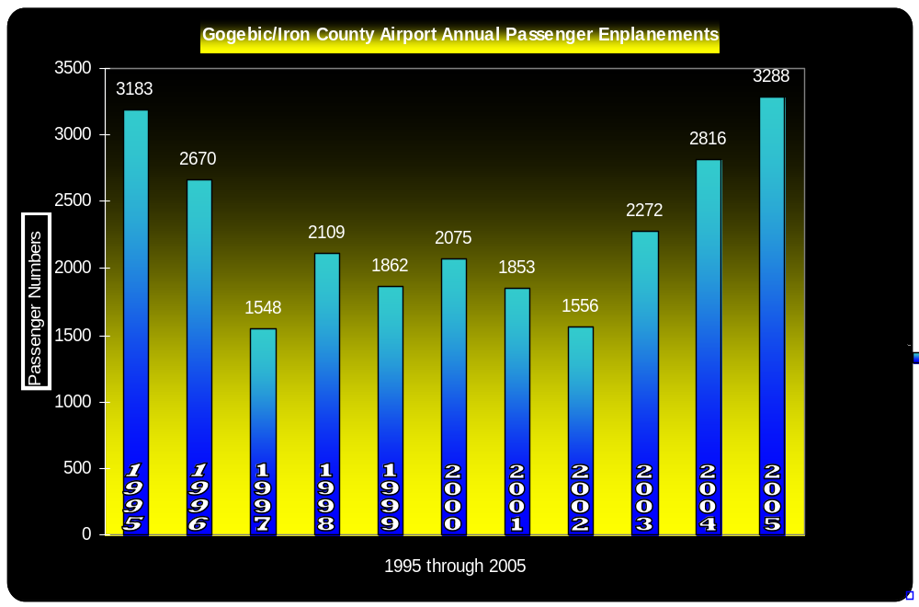
14

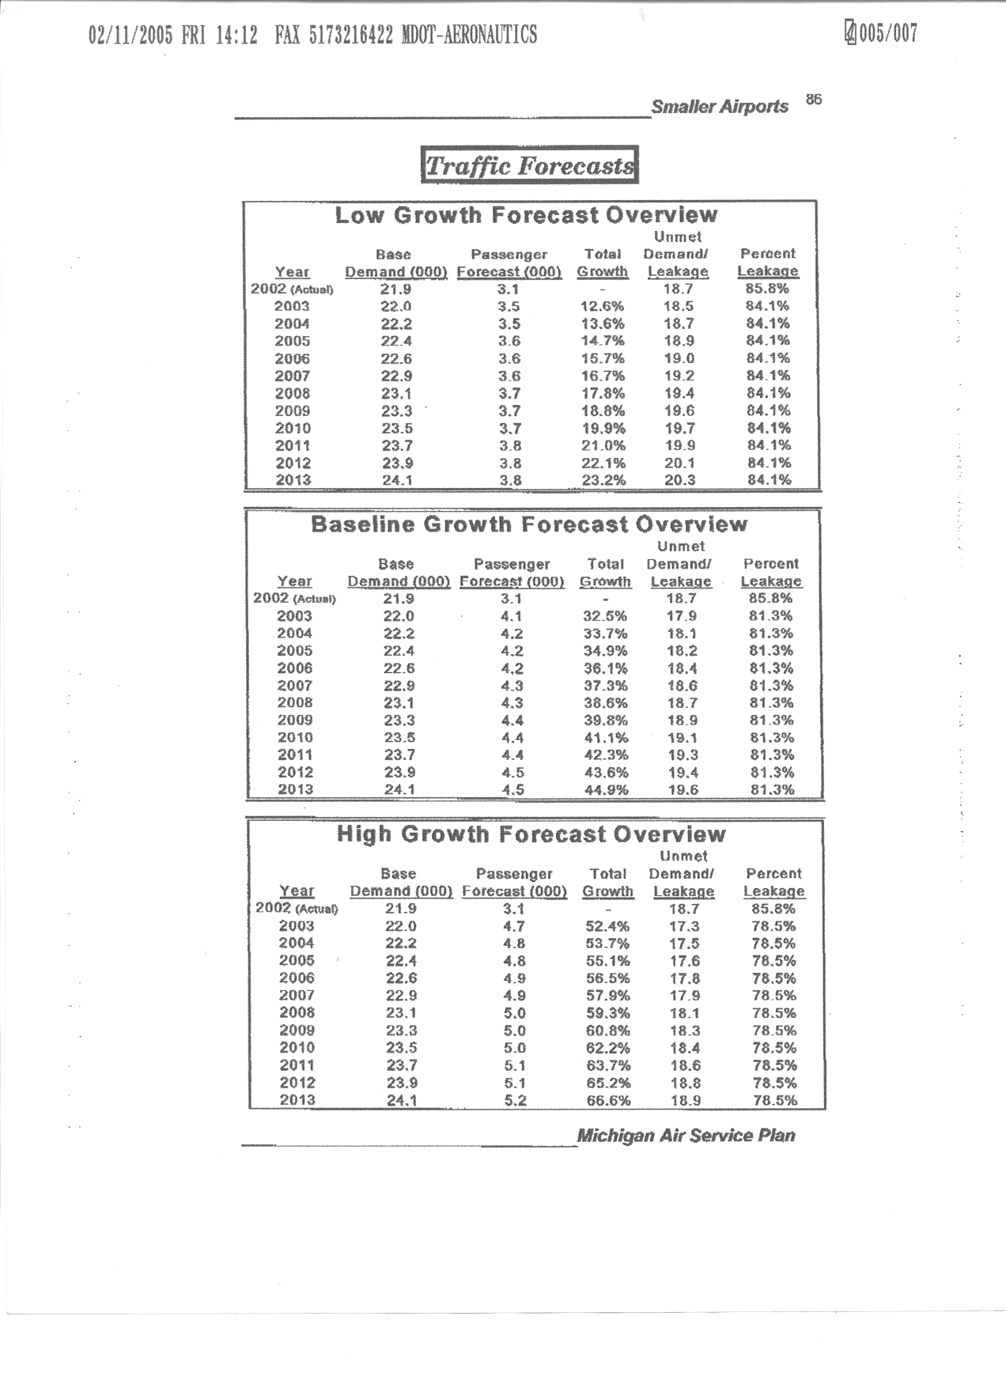
Attachment II
Page 1

Attachment II
Page 1
15
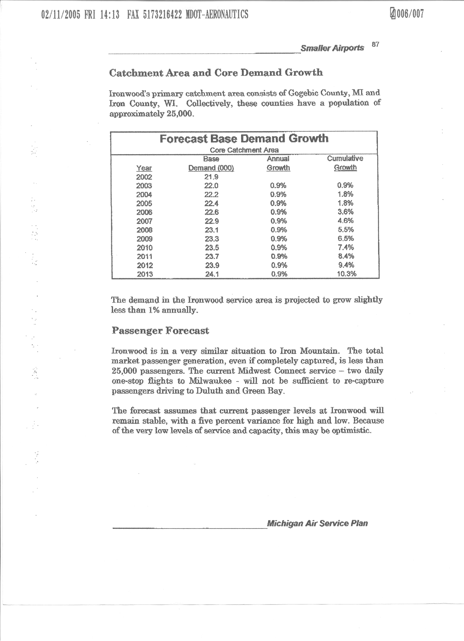

Attachment II
Page 2
16

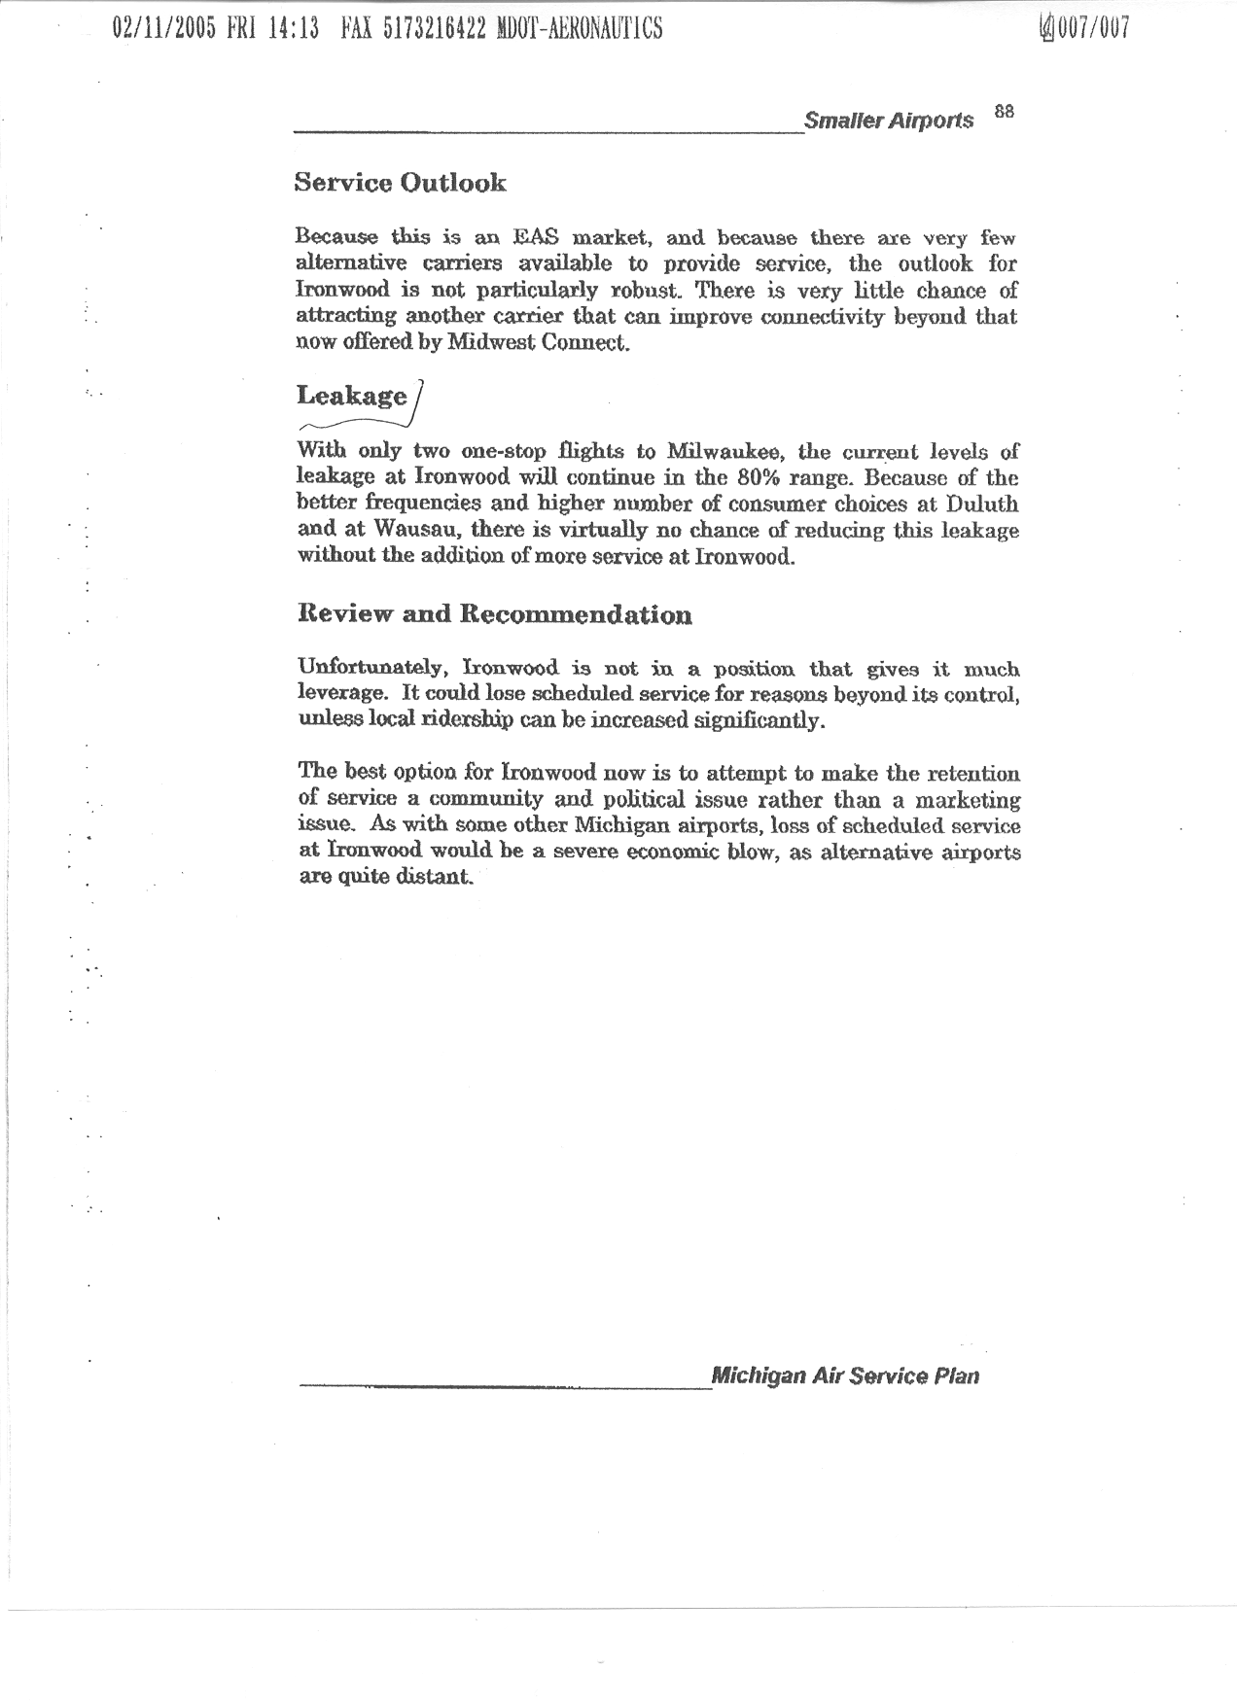

Attachment II
Page 3
17

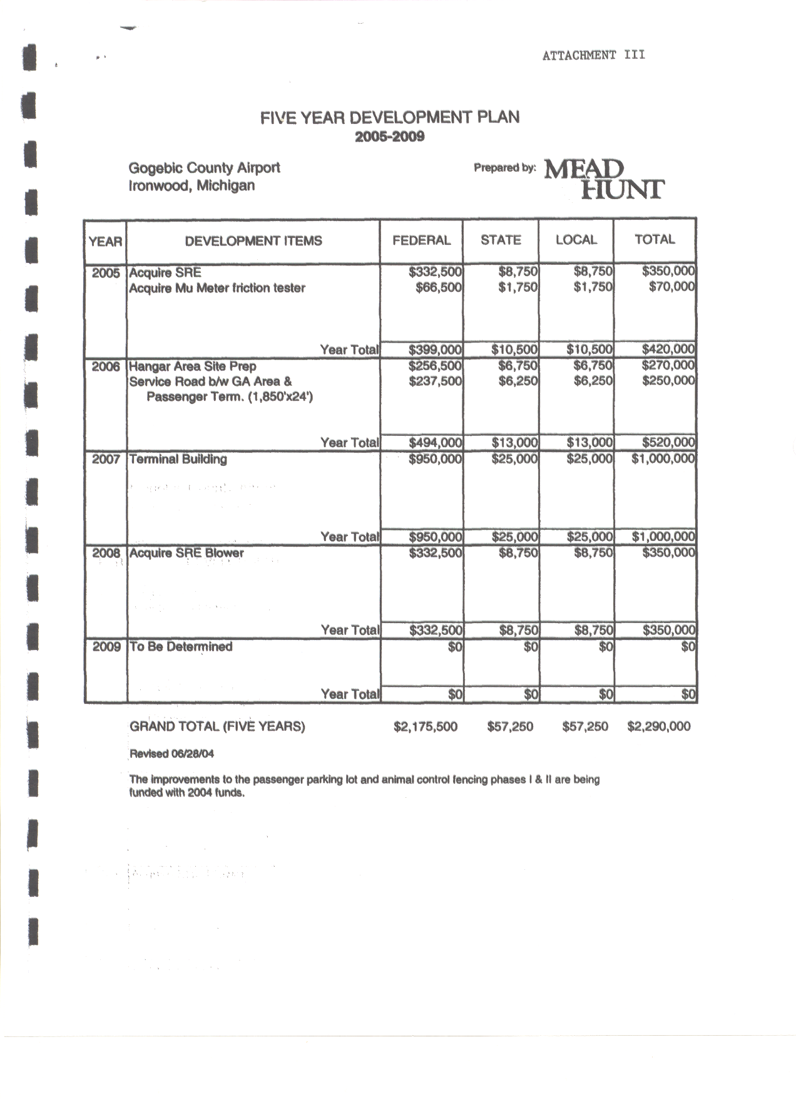
Attachment II
Page 2
Attachment II
Page 3
Page 1
Page 1
18

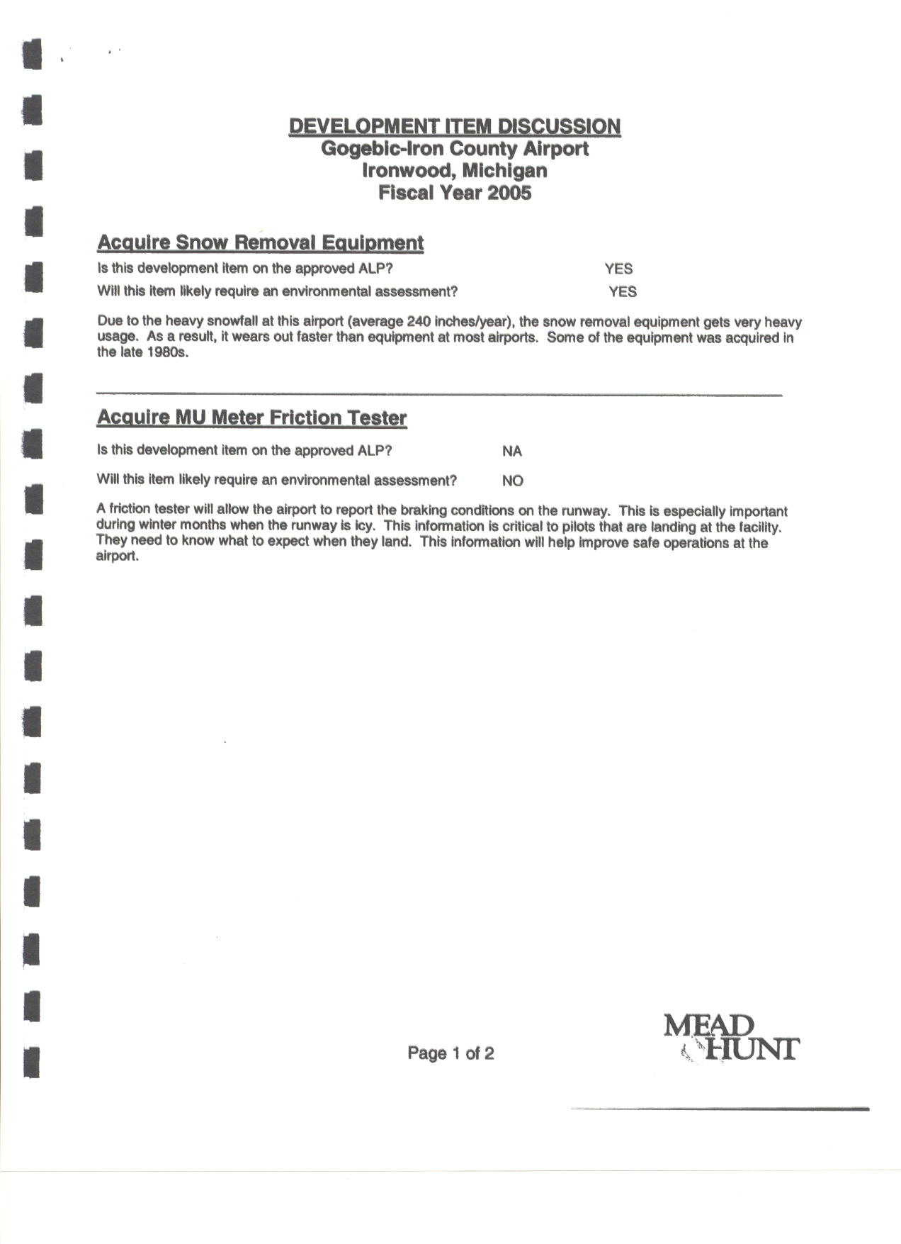

Attachment III
Page 2
19
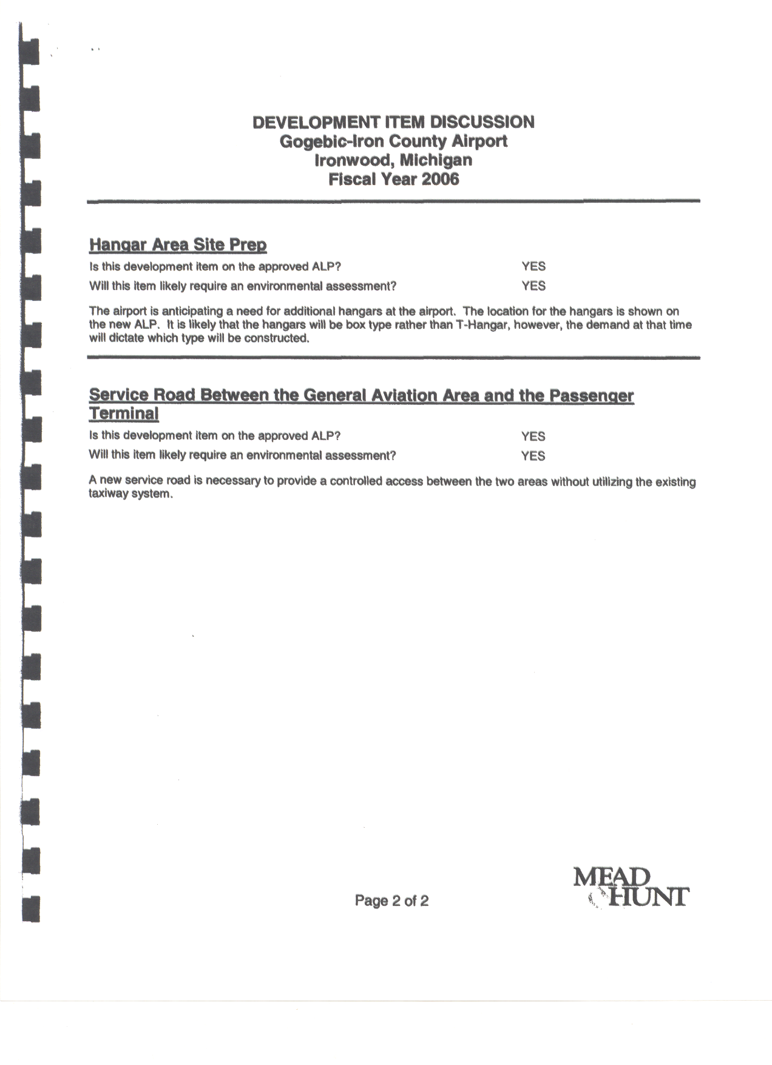
Attachment III
Page 3
20
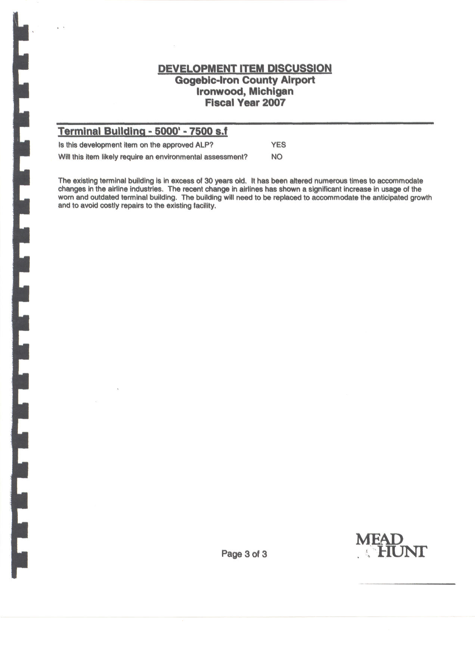
Attachment III
Page 4
21
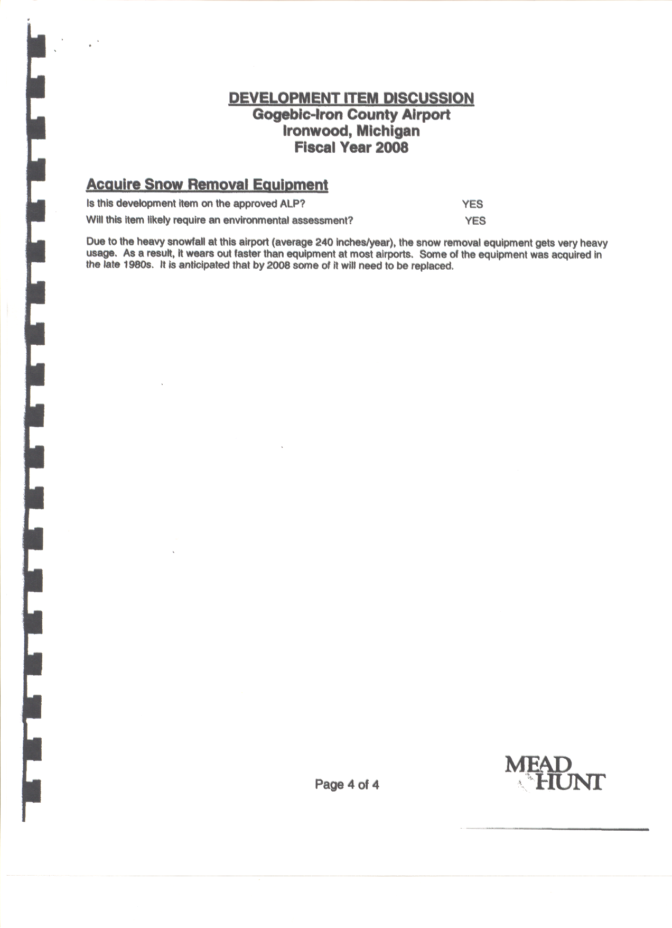
Attachment III
Page 5
22
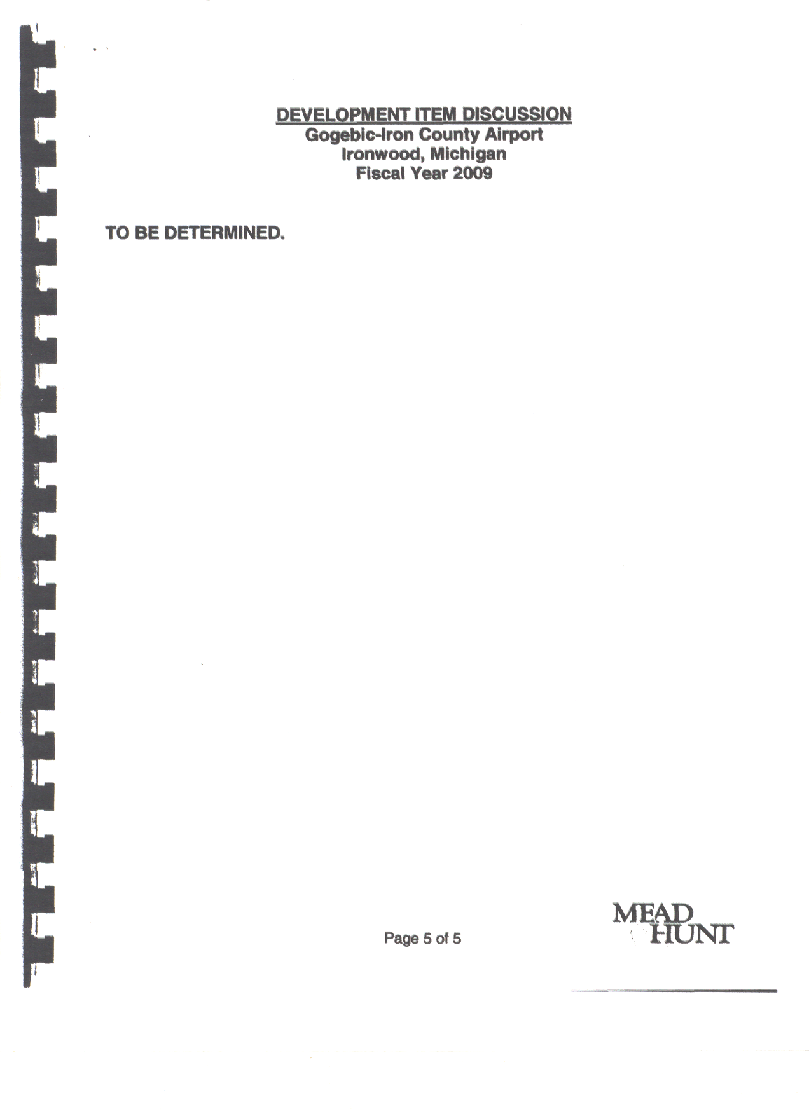
Attachment III
Page 6
23
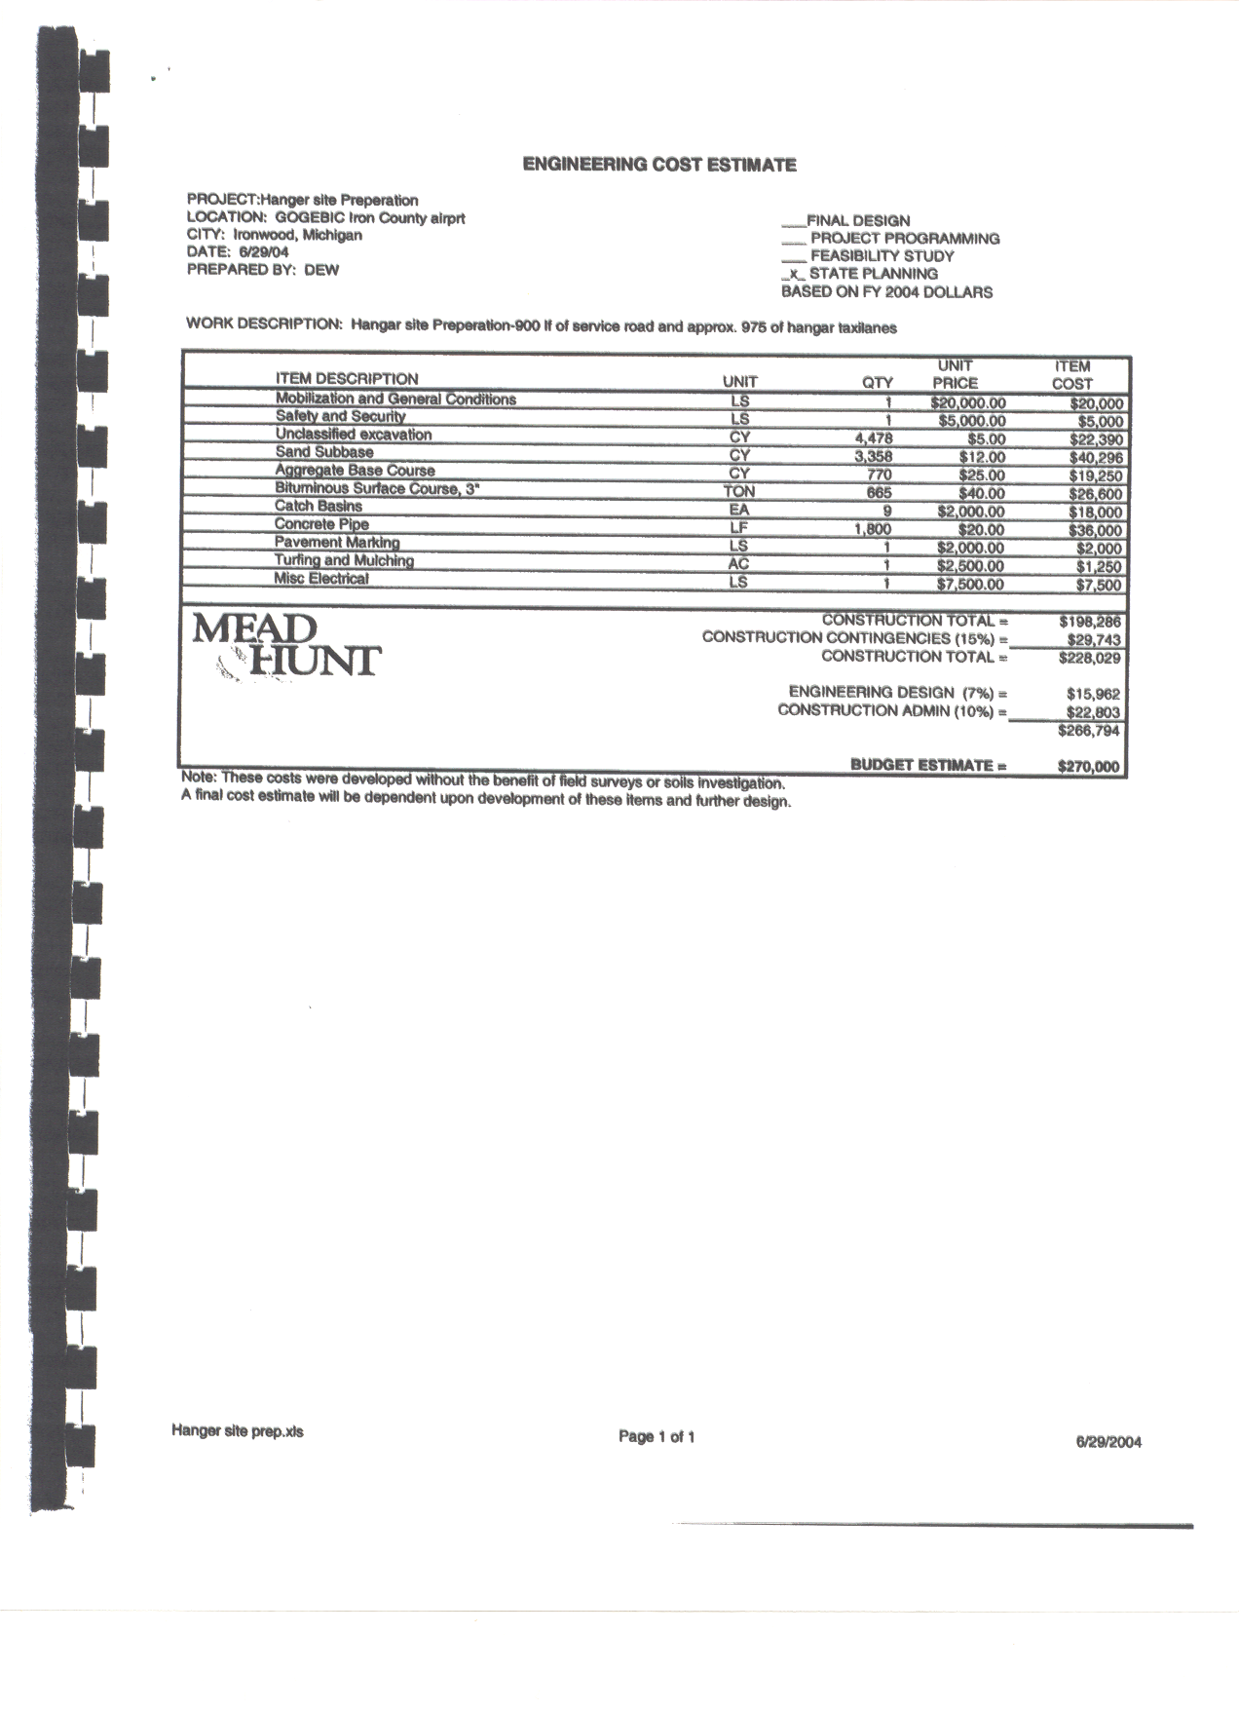

Attachment III
Page 7
24
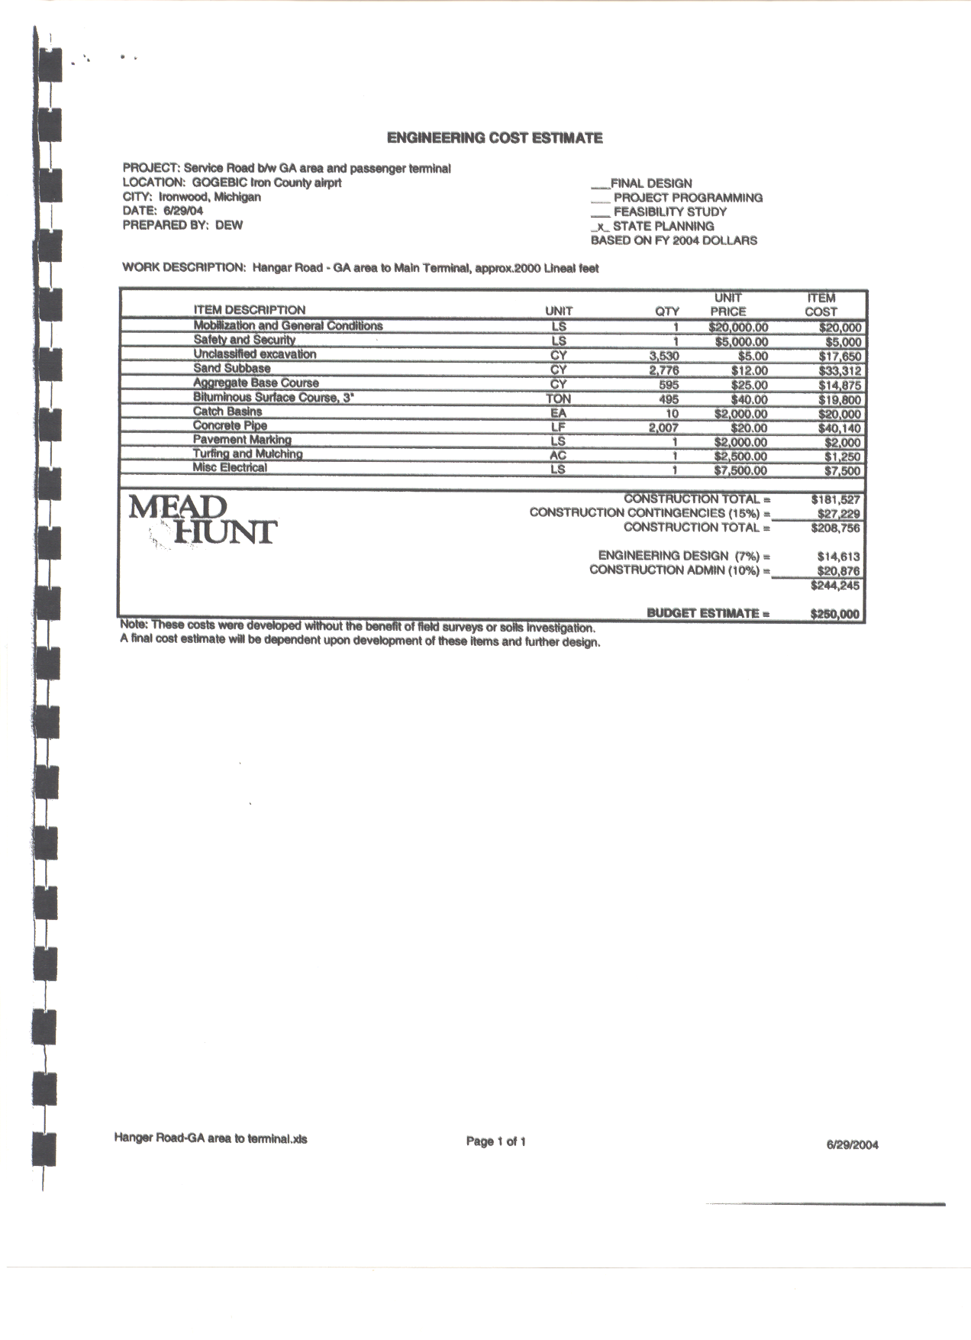

Attachment III
Page 8

Attachment III
Page 8
25

Attachment IV

GOGEBIC-IRON AIRPORT BOARD

JANUARY, 2006

Gene Cisewski, Chairman
202 Copper
Hurley, Wisconsin 54534
715-561-9977

LeRoy Kangas, Vice-Chairman
N10446 Lake Road
Ironwood, Michigan 49938
906-932-4881

Don Richards, Recording Secretary
1075 LaRue Ct.
Hurley, Wisconsin 54534
715-561-5626 (Work)
715-561-4345 (Home)

Keith Winkowski
E8226 U.S. 2
Bessemer, Michigan 49911
906-667-0822 - Work
906-667-0739 - Home

Robert Berg
E8248 Sanders Road
Bessemer, Michigan 49911
906-663-4470 – Home

26

Don Bennetts
410 Hematite
Bessemer, Michigan 49911
906-663-4204

Bob Raisanen
P.O. Box 84
Marenisco, Michigan 49947
906-787-2463 (Work)
906-787-2284 (Home)

Bernie Laird
1090 LaRue Court
Hurley, Wisconsin 54534
1-800-721-4157

David Ramme
501 Margaret Street
Ironwood, Michigan 49938
906-932-5670

